PLAGIARISM REPORT



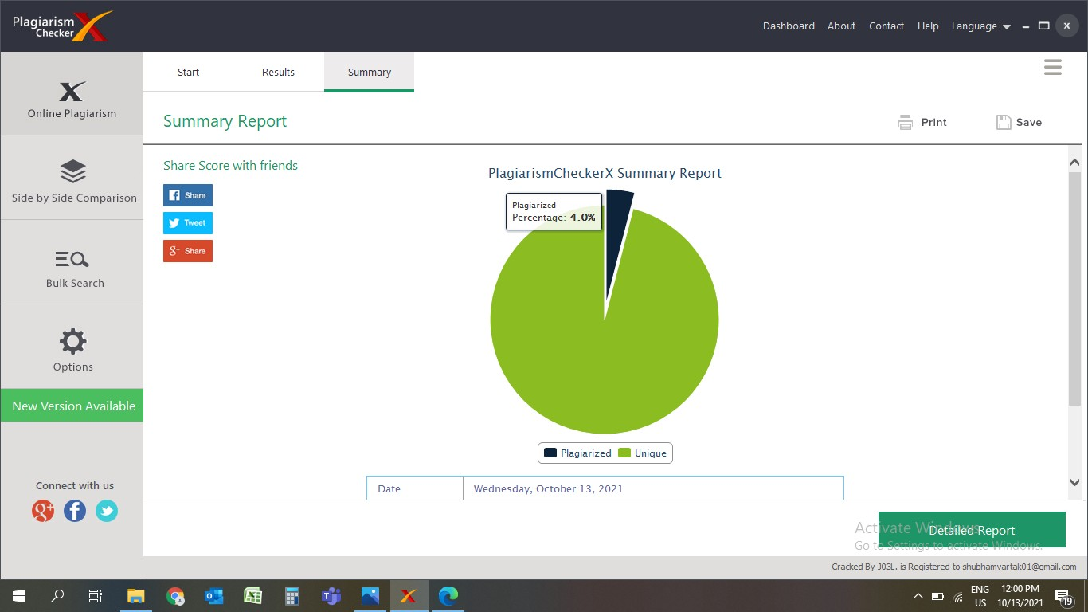

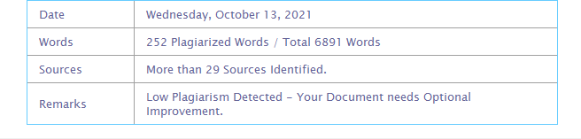

|  |  |  |
| --- | --- | --- |
| **Sr.No.** | **Topic** | **Page No.** |
| 1 | TITLE | 5 |
| 2 | INTRODUCTION | 6 |
| 3 | REQUIREMENT SPECIFICATION | 7 |
| 4 | SYSTEM DESIGN DETAILS | 8 |
| 5 | SYSTEM IMPLEMENTATION | 21 |
| 6 | RESULTS | 116 |
| 7 | FUTURE ENHANCEMENT | 126 |
| 8 | CONCLUSION | 126 |
| 9 | REFERENCES | 126 |
| 10 | ANNEXURE | 127 |

# Introduction

**Society Management System** is provided to society members who can get all the updates related to their society. The members also get notified with notices and events held in society and can see information about members in society. Members can also post complaints regarding any issue in society. The only admin has right to modify the database which holds information of members. Also, the admin can perform tasks that are done by the normal members of this system.

## Objective of the Project:

Objective of Society Management System is to manage all day to day society works, tasks, and for maintaining information about flats, set up reminders for events, and also to maintain complaint register about society and flats in society.

## Description of current system:

In the current framework, all the work is done physically. The notice board is traditional. Hence there is problem of unreachable information & more time consuming. No attention to the individual complaints about flat issues.

## Limitations of current system:

Daily notices, monthly meetings, cultural events, miscellaneous contacts for daily needs, high priority communication and many others which may not be conveyed properly in current scenario as most of the things are getting handled manually, and this lacks transparency and creates conflicts between members.

## Description of Proposed system:

In the proposed system, virtual notice board will be implemented so that notices can be seen from anywhere and will be available to everyone through website. There will be two logins admin and member to ensure the authenticity of things. This will make the entire process paperless and easy to handle by everyone.

## Advantages of Proposed system:

To get attention and notify to important issues and complaints about existing problems (Water, cleanliness, technical works).To maintain transparency between society members and management and to minimize the paperwork load.

It also helps to reduce the efforts for manually communicating with each society member for providing notifications and important information. To keep track society members through database stored. It also helps to manage events, complaints, and to keep society well organized and secure.

# Requirement Specification.

## Software Requirement:

* + - Windows operating system
    - Any browser preferably Google Chrome.
    - XAMPP / WAMP server should be installed on your system.

## Hardware Requirement:

* + - Server with minimum 2 GB space
    - 4 GB ram

## Data Requirement:

* + - Username
    - Password
    - Email id
    - Mobile number
    - Flat number

## Fact Finding Questions:

* + - What work does this system do overall?
    - How many people can play a role of admin in this system?
    - Who will be managing all works in this system?
    - Is our data on this system secured?
    - What is the limit for number of members in the society?
    - How can I update my information?
    - Can admin use this system as normal user?
    - I still have some more queries, where do I contact?
  1. **Event Table:**

# System Design Details

|  |  |  |  |  |  |  |
| --- | --- | --- | --- | --- | --- | --- |
| **No.** | **Event** | **Trigger** | **Source** | **Activity** | **Response** | **Destination** |
| 1. | Register now | form- container | User | Creates new account | Adds new account to db, redirect to home | Server |
| 2. | Login | form- container | User | Checks username and password to login | Redirect to home | Server |
| 3. | Admin | btn | User | Login to admin page | Redirect to admin | Server |
| 4. | User wants to view notice board | View notice | User | Click on to view notice button | Notice section | Local |
| 5. | User wants to submit complaint | Btn- Complaint | User | Submit complaint of user | Add complaint to db, redirect to home | Server |
| 6. | User wants to upload photos | Btn-upload | User,admin | Click to upload photo | To view photo gallery | Server |
| 7. | Logout | Btn logout | User | Logout from account | Redirect to login page | Server |

|  |  |  |  |  |  |  |
| --- | --- | --- | --- | --- | --- | --- |
| 8. | Add member | Btn-add | Admin | Click to add newMember | Redirect to manage members | Server |
| 9. | Update member | Btn-update | Admin | Click to update member | Redirect to manage members | Server |
| 10. | Delete member | Btn-Delete | Admin | Click to delete member. | Redirect to manage members | Server |
| 11. | Add notice | Btn-notice | Admin | Click to add notice. | Redirect to add notice | Server |
| 12. | View complaints | Btn- complaints | Admin | Click to view complaints | Redirect to View Complaints | Server |
| 13. | Logout | Btn-Logout | Admin | Click to logout | Rdirect to admin login page | Server |

## Class Diagram:

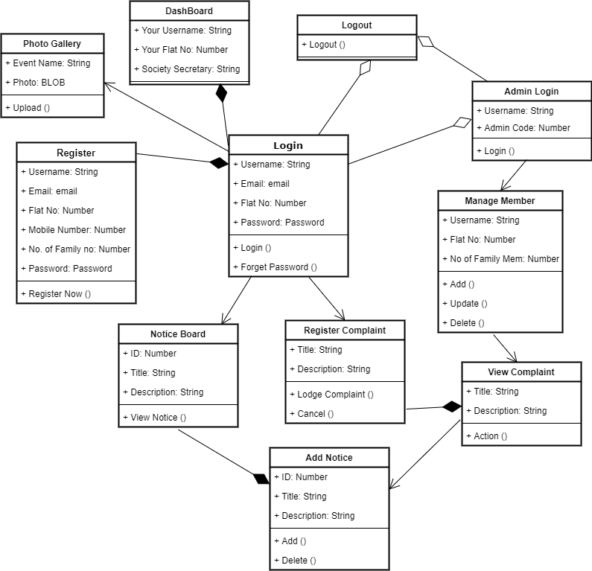

Figure 4.2: Class Diagram

## Use Case Diagram:

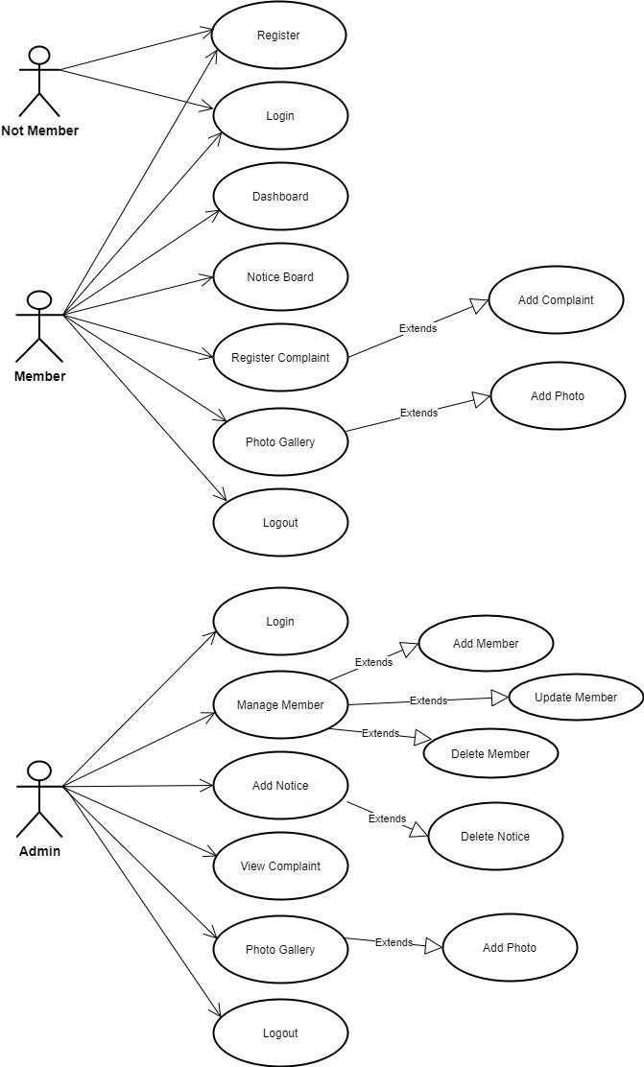

Figure 4.3: Use Case Diagram

## Sequence Diagram:

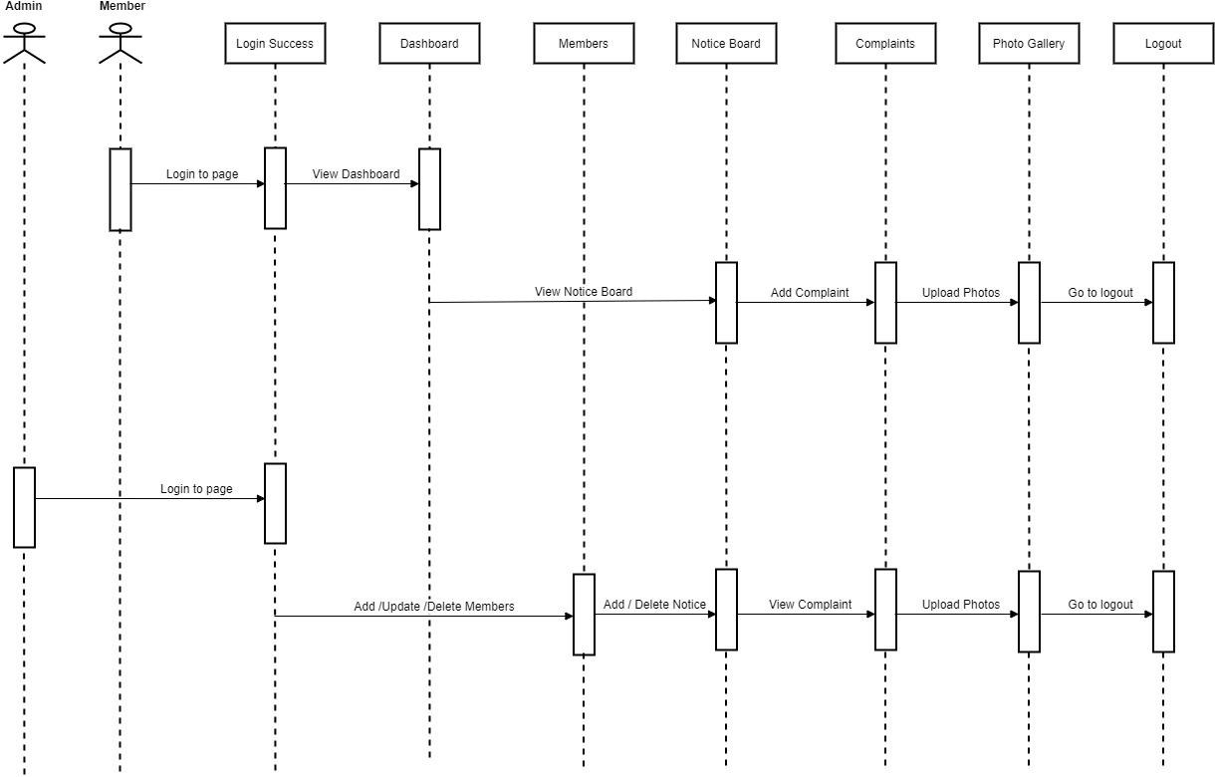

Figure 4.4: Sequence Diagram

## Activity Diagram:

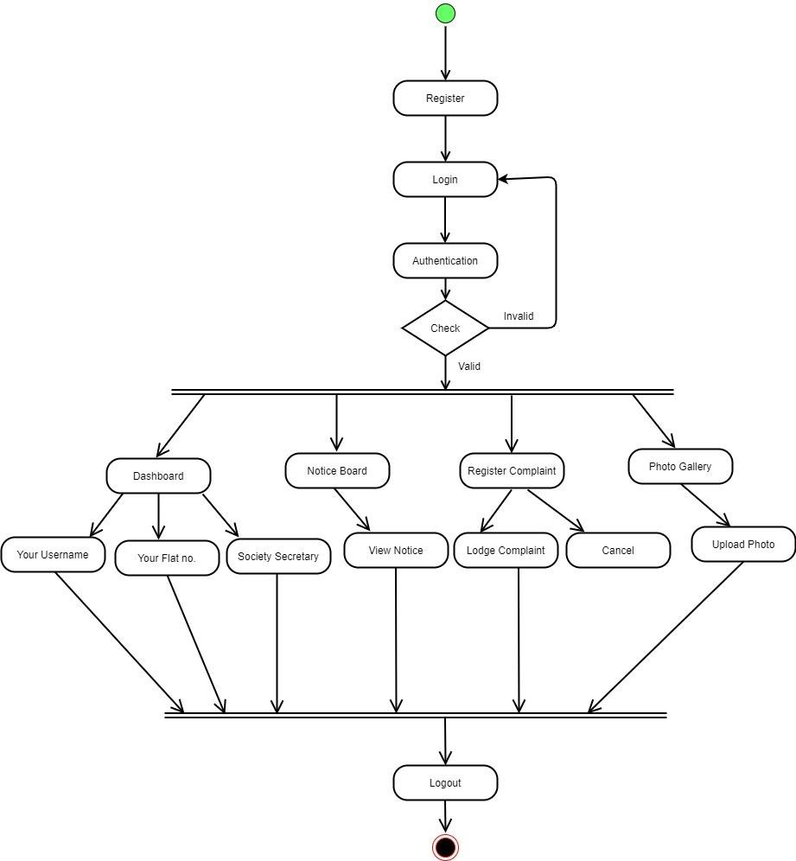

Figure 4.5: Activity Diagram for User

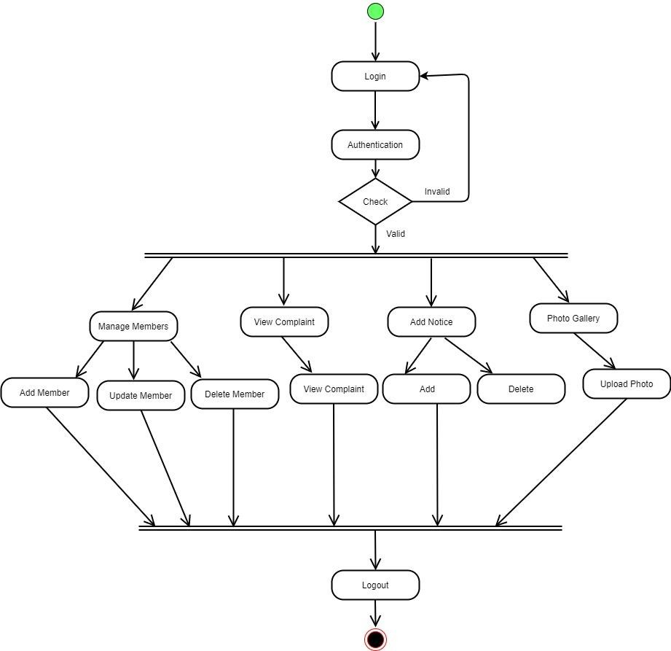

Figure 4.5: Activity Diagram for Admin

## State Diagram:

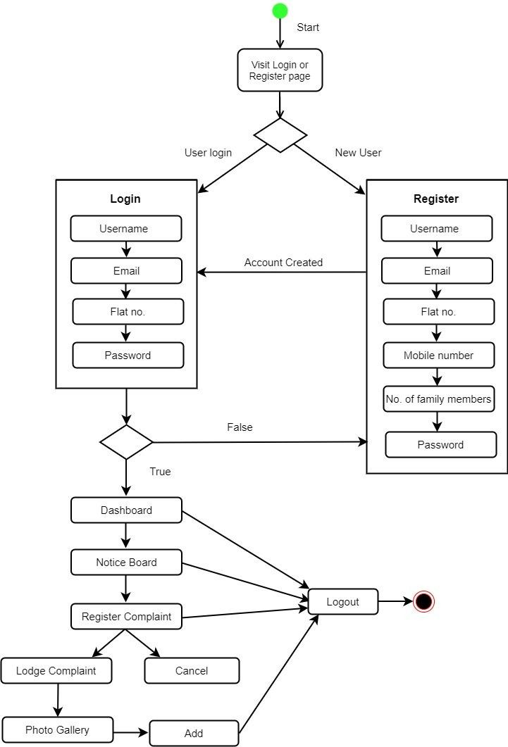

Figure 4.6: State Diagram User

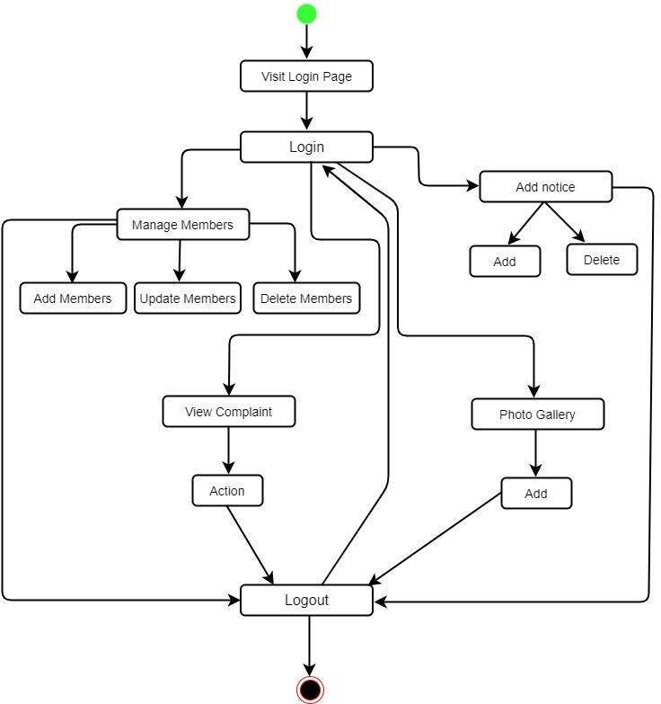

Figure 4.6: State Diagram for Admin

## Package Diagram:

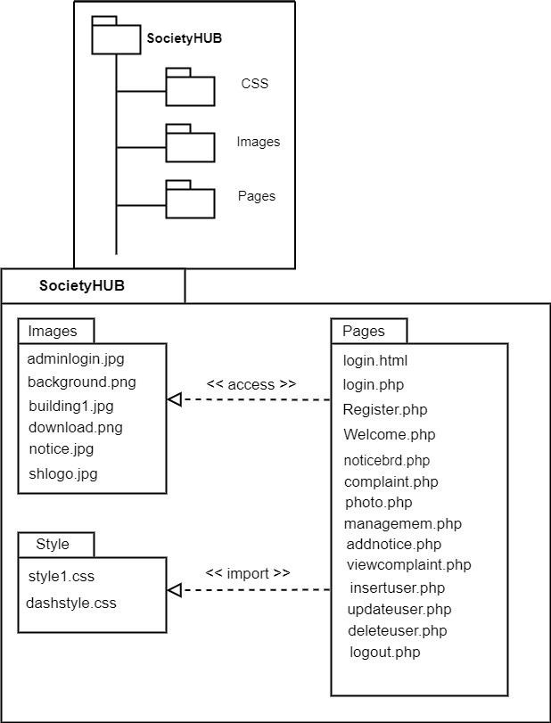

Figure 4.7: Package Diagram

## Component Diagram:

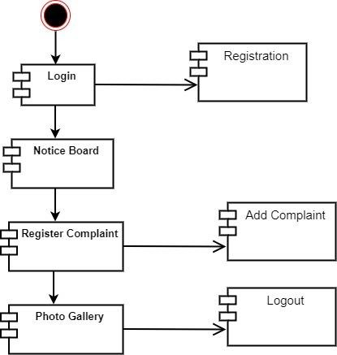

Figure 4.8: Component Diagram

## Deployment Diagram:

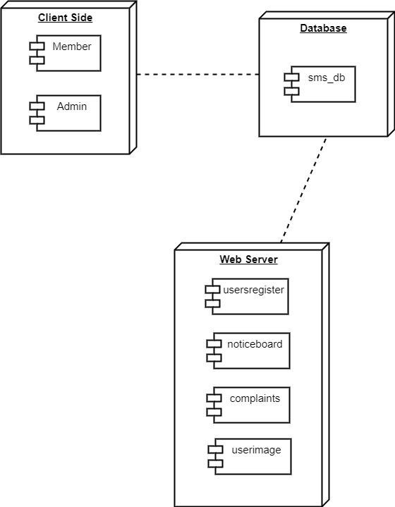

Figure 4.9: Deployment Diagram

## Database Design:

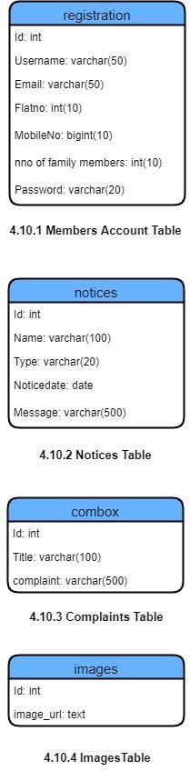

Figure 4.10: Database Design

# System Implementation.

## Login.html

<!DOCTYPE html>

<html lang="en">

<head>

<meta charset="UTF-8">

<meta http-equiv="X-UA-Compatible" content="IE=edge">

<meta name="viewport" content="width=device-width, initial-scale=1.0">

<title>SocietyHub</title>

<link rel="stylesheet" href="style1.css">

<script src="https://kit.fontawesome.com/2edfbc5391.js"crossorigin="anonymous"></script>

</head>

<body>

<div class="page">

<div class="navbar">

<img src="img/shlogo.jpg" class="logo">

<h1>Society<span style="font-family: 'Merienda', cursive; color:rgb(20, 76, 80);">HUB</span></h1>

<nav>

<ul>

<li><a href=""class="active">Home</a></li>

<li><a href="#rules">Rules & Regulations</a></li>

</ul>

</nav>

<a href="Adminlogin.php" class="btn">Admin Login</a>

</div>

<div class="row">

<div class="col-1">

<img src="img/building1.jpg" >

</div>

<div class="col-2">

<div class="form-container">

<div class="form-btn">

<span onclick="login()">Login</span>

<span onclick="register()">Register</span>

<hr id="indicator">

</div>

<form action="login.php" method="POST" id="Loginform">

<input type="text" placeholder="Username" name="username" required>

<input type="email" placeholder="E-mail" name="email" required>

<input type="text" placeholder="Flat-No." name="flatno" required>

<input type="password" placeholder="Password" name="password" required>

<button type="submit" class="btn-losi">Login</button><br>

<a href="">Forget Password...???</a>

</form>

<form action="register.php" method="POST" id="Regform">

<input type="text" placeholder="Username" name="username" required>

<input type="email" placeholder="E-mail" name="email" required>

required>

<input type="text" placeholder="Flat-No." name="flatno" required>

<input type="tel" placeholder="Mobile Number" name="mobno" required>

<input type="text" placeholder="Number of Family members" name="fammem"

<input type="password" placeholder="Password" name="password" required>

<button type="submit" class="btn-losi" >Register Now</button>

</form>

</div>

</div>

</div>

</div>

<hr>

<div id="rules">

<h1>Rules and Regulations</h1>

<hr>

<li>Members and residents are required to keep their flats/homes and nearby premises clean and habitable.</li>

<li>The residents should also maintain proper cleanliness etiquette while using common areas, parking lot, etc. and not throw litter from their balconies and windows.</li>

<li>Members must regularly pay the maintenance charges and all other dues necessitated by the society.</li>

<li>Keeping pets is allowed after submitting the required NOC to the society. But if pets like dogs are creating any kind of disturbance to other society members then the pets won’t be allowed.</li>

<li>Every member of the society should park their vehicles in their respective allotted parking spaces only.</li>

<li> After using the community hall for any event or function it should be cleaned and no damages should be caused.</li>

<li>No member can occupy the area near their front doors, corridors, passage for their personal usage.</li>

<li>Salesmen, vendors or any other sellers are not allowed to enter the premises.</li>

<li>Wastage and over usage of water is not allowed.</li>

<li>Smoking in lobbies, passage is not allowed. If any irresponsible person is found smoking in the no smoking zone, he/she shall be charged with penalty.</li>

</div>

<!-- footer code -->

<hr>

<footer>

<div class="main-content">

<div class="left box">

<h2>About Us</h2>

<div class="content">

<p>

SocietyHUB is webapp where society members can get all the updates related to their society. The members also get notified with notices and events held in society and can see information about members in society. Members can also post complaints regarding any issue in society.

</p>

</div>

</div>

<div class="center box adjust">

<div class="cen">

<h2>Quick Links</h2>

<ul>

<li><a href="login.html">Home</a></li>

<li><a href="#Loginform">Login</a></li>

<li><a href="#rules">Rules and Regulations</a></li>

</ul>

</div>

</div>

<div class="right box">

<h2>Address</h2>

<div class="content">

<div class="place">

<span class="fas fa-map-marker-alt"></span>

<span class="text">Thanekar Parkland,Badlapur(E)</span>

</div>

<div class="phone">

<span class="fas fa-phone-alt"></span>

<span class="text">+91 8779635278</span>

</div>

<div class="email">

<span class="fas fa-envelope"></span>

<span class="text">[societyHUB@gmail.com<](mailto:societyHUB@gmail.com)/span>

</div>

</div>

</div>

</div>

<div class="copyright">

<h3>Copyright @2021|Designed with HTML,CSS,PHP.</h3>

</div>

</footer>

<script>

var Loginform=document.getElementById("Loginform") var Regform=document.getElementById("Regform")

var indicator=document.getElementById("indicator")

function register(){

Regform.style.transform= "translateX(0px)"; Loginform.style.transform= "translateX(0px)"; indicator.style.transform= "translateX(80px)";

}

function login(){

Regform.style.transform= "translateX(300px)"; Loginform.style.transform= "translateX(300px)"; indicator.style.transform= "translateX(0px)";

}

</script>

</body>

</html>

<?php

## Register.php

if ($_SERVER['REQUEST_METHOD'] == 'POST'){

$Username = $_POST['username'];

$email = $_POST['email'];

$flatno = $_POST['flatno'];

$mobileno = $_POST['mobno'];

$familymem = $_POST['fammem'];

$Password = $_POST['password'];

}

// connecting to database

$servername = "localhost";

$username = "root";

$password = "";

$database = "usersregister";

// creating connection

$conn = mysqli_connect($servername, $username, $password, $database);

// die if connection was not successfull

if (!$conn){

die("Sorry we failed to connect:". mysqli_connect_error());

}

else{

// submitting to database

$sql = "INSERT INTO `registration` ( `Username`, `Email`, `Flatno`, `MobileNo`, `nno of family members`, `Password`) VALUES ( '$Username', '$email', '$flatno', '$mobileno', '$familymem', '$Password')";

$result = mysqli_query($conn, $sql);

if($result){

echo "<script>alert('Registration successfull...you may now login.'); window.location.href = 'login.html';

</script>";

}

else{

echo "<script>alert('Registration Failed...Please try again.!!'); window.location.href = 'login.html';

</script>";

}

}

?>

<?php

## login.php

if ($_SERVER['REQUEST_METHOD'] == 'POST'){

$Username = $_POST['username'];

$email = $_POST['email'];

$flatno = $_POST['flatno'];

$Password = $_POST['password'];

}

// connecting to database

$servername = "localhost";

$username = "root";

$password = "";

$database = "usersregister";

// creating connection

$conn = mysqli_connect($servername, $username, $password, $database);

// die if connection was not successfull

$sql = "Select * from registration where username='$Username' AND flatno='$flatno'";

$result = mysqli_query($conn,$sql);

$num = mysqli_num_rows($result);

if ($num == 1){

echo "<script>alert('Welcome,You are logged in...!'); window.location.href = 'Welcome.php';

</script>"; session_start();

$_SESSION['loggedin']= true;

$_SESSION['username']= $Username;

}

else{

echo "<script>alert('Sorry,Invalid credentials...!'); window.location.href = 'login.html';

</script>"; mysqli_error($conn);

}

?>

## Style1.CSS

*{

margin: 0;

padding: 0;

}

.page{

height: 110vh; width: 100%;

background-image: linear-gradient(rgb(211, 203, 241),rgb(205, 232, 241)); background-position: center;

background-size:cover; padding-left: 5%;

padding-right: 5%;

box-sizing: border-box; overflow-x: hidden; position:relative;

}

.navbar{ width: 150%; height: 15vh; margin: auto; display:flex;

align-items: center;

/* justify-content: space-between; */

}

.logo{

height: 80px; width: 80px; cursor: pointer;

/* padding-top: 20px; */

/* padding-right: 45px; */ border-radius: 60px;

}

nav{

flex:1;

padding-left: 100px;

/* display: flex;

justify-content: space-between; */

}

nav ul li{

display: inline-block; list-style: none; margin: 0px 25px;

/* padding-left: 150px; */ position: relative;

}

nav ul {

padding-left: 246px;

}

nav ul li::after{ content:""; height: 3px; width: 0%;

background:rgb(5, 85, 85); position: absolute;

left: 0px; bottom: -5px; transition: 0.5s;

}

nav ul li:hover::after{ width: 100%;

}

nav ul li a{

text-decoration: none; font-size: 24px; color: rgb(5, 85, 85);

}

.navbar h1{

padding-top: 10px; margin-left: 8px; font-size: 30px;

font-family: 'Mate', serif;

color: rgb(51, 123, 133); cursor: pointer;

}

/* span{

font-family: 'Merienda', cursive; color:rgb(20, 76, 80);

} */

.row{

display: flex; flex-wrap: wrap; margin-top: 5%;

justify-content: space-between;

}

.col-1{

flex-basis: 40%; min-width:200px;

margin-bottom: 40px;

}

.col-1 img{ width: 115%;

height: 110%;

/* padding-right: 20px; */

/* padding-left: 30px; */ border-radius: 40px; cursor: pointer;

}

.active::after{ content: ""; height: 3px; width: 100%;

background:rgb(5, 85, 85); position: absolute;

left: 0px; bottom: -5px;

/* text-decoration:underline rgb(5, 85, 85); */

}

.btn{

margin-left: 1083px;

/* margin-right: 130px; */ margin-top: 0px;

/* background: #fff; */ color:rgb(5, 85, 85) ; font-weight: 500px;

border: 2px solid rgb(5, 56, 77); padding: 6px 25px;

border-radius: 60px; text-decoration: none; position:absolute; transition: 0.5s

}

.btn:hover{ background: #fff;

}

.form-container{ background: #fff; width: 300px; height: 400px; position: relative; text-align: center; padding: 10px 0; margin: auto;

box-shadow: 0 0 20px 0px rgba(0,0,0,0.1); overflow: hidden;

}

.col-2{

padding-right: 150px; padding-top: 32px;

}

.form-container span{ font-weight: bold; padding: 0 10px;

color: #555; cursor: pointer; width: 50px;

display: inline-block;

}

.form-btn{

display: inline-block; padding-top: 21px;

}

.form-container form{ max-width: 300px;

/* padding: 0 20px; */ position: absolute; top: 130px;

transition: transform 1s;

}

form input{ width: 80%; height: 30px;

margin-top: 0px; margin-bottom: 10px; padding: 0 10px; border: 1px solid #ccc;

}

#Loginform{ left:-300px; top: 110px;

}

#Regform{ left: 0; top: 90px;

}

form a{

font-size: 18px; display: block;

}

#indicator{ width: 65px; border: none;

background: rgb(5, 85, 85); height: 3px;

margin-top: 8px;

transform: translateX(80px); transition: transform 1s;

}

.btn-losi{

width: 75%;

font-weight: bold; padding: 10px 10px; cursor: pointer; display: block;

margin: 14px 40px 0px;

background:linear-gradient(to right,#a7cceb,#95b1bd); border: 0;

outline: none; border-radius: 30px;

}

.btn-losi:hover{

background: rgb(109, 159, 201);

}

#rules {

height: 80vh; width: 100%;

background-size:cover; box-sizing: border-box; overflow-x: hidden; position:relative;

}

#rules h1{

padding-top: 15px; padding-bottom: 15px; padding-left: 523px; color: rgb(5, 85, 85);

background-color: aliceblue;

}

#rules li{

list-style:number;

list-style-position:outside; text-indent: -1em;

font-family: Cambria, Cochin, Georgia, Times, 'Times New Roman', serif; font-weight: bold;

padding-top: 15px; padding-left: 28px; font-size: 18px;

}

footer{

position:relative; width: 100%;

background: rgb(27, 78, 87); font-family: 'poppins',sans-serif; color: #d9d9d9;

box-sizing: border-box;

}

.main-content{ display: flex;

}

.main-content .box{ flex-basis: 50%; padding: 10px 20px;

}

.box h2{

font-size: 1.125rem; font-weight: 600;

text-transform: uppercase; padding-top: 15px;

/* padding-left: 143px; */

}

.box h2:hover{

color: rgb(39, 159, 228);

}

.box .content{ margin: 20px 0 0 0;

}

.left .content p{

text-align: justify;

}

.content p{

line-height: 20px;

}

.place{

padding-bottom: 10px;

}

.phone{

padding-bottom: 10px;

}

.link{

width: 20%;

}

ul li{

list-style-type: none; padding-top: 20px;

}

ul li a{

color: #fff;

text-decoration: none;

}

.adjust ul li a:hover{

color: rgb(17, 195, 201);

}

.cen{

padding-left: 100px;

}

.copyright h3{

font-family: Cambria, Cochin, Georgia, Times, 'Times New Roman', serif; background-color:#416d74;

text-align: center; font-size: 15px; height: 23px;

}

## Dashstyle.CSS

body{

margin: 0;

padding: 0;

font-family: "Roboto", sans-serif;

}

header{ position:fixed;

background: #22242A; padding: 20px;

width: 100%; height: 30px;

}

.left_area h3{ color: #fff; margin: 0;

text-transform: uppercase; font-size: 22px;

font-weight: 900;

}

.left_area span{ color: #19B3D3;

}

.logout_btn{ padding: 5px;

background: #19B3D3; text-decoration: none; float: right;

margin-top: -30px; margin-right: 40px; border-radius: 2px; font-size: 15px; font-weight: 600; color: #fff; transition: 0.5s;

transition-property: background;

}

.logout_btn:hover{ background: #0B87A6;

}

.sidebar {

background: #2f323a; margin-top: 70px; padding-top: 30px; position: fixed;

left: 0;

width: 250px; height: 100%; transition: 0.5s;

transition-property: left;

}

.sidebar .profile_image{ width: 100px;

height: 100px;

border-radius: 100px; margin-bottom: 10px;

}

.sidebar h4{ color: #ccc; margin-top: 0;

margin-bottom: 20px;

}

.sidebar a{ color: #fff; display: block; width: 100%;

line-height: 60px;

text-decoration: none; padding-left: 40px;

box-sizing: border-box;

/* transition: 0.5s;

transition-property: background; */

}

.sidebar a:hover{ background: #19B3D3;

}

.sidebar.active{ background: #19B3D3;

}

.sidebar i{

padding-right: 10px;

}

label #sidebar_btn{ z-index: 1;

color: #fff; position: fixed; cursor: pointer; left: 300px; font-size: 20px;

margin: 5px 0; transition: 0.5s;

transition-property: color;

}

label #sidebar_btn:hover{ color: #19B3D3;

}

#check:checked ~ .sidebar{ left: -190px;

}

#check:checked ~ .sidebar a span{ display: none;

}

#check:checked ~ .sidebar a{ font-size: 20px;

margin-left: 170px; width: 80px;

}

.content{

margin-left: 250px;

overflow: auto;

background: url(img/background.png) no-repeat; background-position: center;

background-size: cover; height: 100vh; transition: 0.5s;

}

.content h1{ padding-top: 65px; padding-left: 10px;

}

.col-div-3{ width: 25%; float: left;

}

.box{

width: 85%; height: 100px;

background-color: #272c4a; margin-left: 10px;

padding: 10px; cursor: pointer;

}

.box p{

font-size: 35px;

color: white;

font-weight: bold; line-height: 30px; padding-left: 10px; margin-top: 20px; display: inline-block;

}

.box p span{ font-size: 20px;

font-weight: 400;

color: #818181;

}

.box-icon{

font-size: 40px!important; float: right;

margin-top: 35px!important; color: #818181;

padding-right: 10px;

}

#check:checked ~ .content{ margin-left: 60px;

}

#check{ display: none;

}

## Welcome.php

<?php session_start();

if(!isset($_SESSION['loggedin']) || $_SESSION['loggedin']!=true){ header("location: login.html");

exit;

}

?>

<!DOCTYPE html>

<html lang="en">

<head>

<meta charset="UTF-8">

<meta http-equiv="X-UA-Compatible" content="IE=edge">

<meta name="viewport" content="width=device-width, initial-scale=1.0">

<title>Welcome dashboard</title>

<link rel="stylesheet" href="dashstyle.css">

<script src="https://kit.fontawesome.com/2edfbc5391.js"crossorigin="anonymous"></script>

<style>

.far{ color:#a7abde;

padding-left: 15px;

}

.col-div-3 .box p{ font-size: 25px;

}

.box .fas{ color:#a7abde; position:absolute; padding-top: 50px;

}

.box .fas .fa-home{ color:#a7abde; padding-left: 20px;

}

</style>

</head>

<body>

<input type="checkbox" id="check">

<!--header area start-->

<header>

<label for="check">

<i class="fas fa-bars" id="sidebar_btn"></i>

</label>

<div class="left_area">

<h3>Society<span>HUB</span></h3>

</div>

<div class="right_area">

<a href="logout.php" class="logout_btn">Logout</a>

</div>

</header>

<!--header area end-->

<!--sidebar start-->

<div class="sidebar">

<center>

<img src="img/download.png" class="profile_image" alt="">

<h4> <?php echo $_SESSION['username']?> </h4>

</center>

<a href="Welcome.php" class="active"><i class="fas fa- desktop"></i><span>Dashboard</span></a>

<a href="noticebrd.php"><i class="fas fa-bullhorn"></i><span>Notice Board</span></a>

<a href="complaint.php"><i class="fas fa-envelope-open-text"></i><span>Register Complaint</span></a>

<a href="userphoto.php"><i class="fas fa-camera-retro"></i><span>Photo Gallery</span></a>

<!-- <a href="#"><i class="fas fa-info-circle"></i><span>About</span></a>

<a href="#"><i class="fas fa-sliders-h"></i><span>Settings</span></a> -->

</div>

<!--sidebar end-->

<div class="content">

<h1>Welcome to Dashboard</h1>

<?php

$servername = "localhost";

$username = "root";

$password = "";

$database = "usersregister";

// creating connection

$conn = mysqli_connect($servername, $username, $password, $database);

$user_name = $_SESSION['username'];

$sql = "SELECT Username,Flatno FROM registration where Username='$user_name'";

$result = $conn->query($sql); if($result->num_rows >0){

while($row = $result->fetch_assoc()){

echo '<div class="col-div-3">

<div class="box">

<p>'.$row['Username'].'<br><span>Your Username</span></p>

<i class="far fa-user fa-2x"></i>

</div>

</div>

<div class="col-div-3">

<div class="box">

<p>'.$row['Flatno'].'

<br><span>Your Flat No.</span></p>

<i class="fas fa-home fa-2x"></i>

</div>

</div>

<div class="col-div-3">

<div class="box">

<p>Shubham Vartak<br><span>Society Secretary</span></p>

<i class="fas fa-user-tie fa-2x" ></i>

</div>

</div>';

}}else {

echo "O records found !";

}

?>

</div>

</body>

</html>

## Noticebrd.php

<?php session_start();

if(!isset($_SESSION['loggedin']) || $_SESSION['loggedin']!=true){ header("location: login.html");

exit;

}

?>

<!DOCTYPE html>

<html lang="en">

<head>

<meta charset="UTF-8">

<meta http-equiv="X-UA-Compatible" content="IE=edge">

<meta name="viewport" content="width=device-width, initial-scale=1.0">

<title>Notice Board</title>

<link rel="stylesheet" href="dashstyle.css">

<script src="https://kit.fontawesome.com/2edfbc5391.js"crossorigin="anonymous"></script>

<style>

.content-table {

border-collapse: collapse; margin: 25px 19px; margin-left: 13px;

font-size: 0.9em; min-width: 400px;

border-radius: 5px 5px 0 0;

overflow: hidden;

box-shadow: 0 0 20px rgba(0, 0, 0, 0.15);

}

.content-table thead tr { background-color: #19B3D3; color: #ffffff;

text-align: left; font-weight: 900;

}

.content-table th,

.content-table td { padding: 15px 15px;

}

.content-table tbody tr {

border-bottom: 1px solid #dddddd;

}

.content-table tbody tr:nth-of-type(even) { background-color: #f3f3f3;

}

.content-table tbody tr:last-of-type { border-bottom: 2px solid #82abc7;

}

</style>

</head>

<body>

<input type="checkbox" id="check">

<!--header area start-->

<header>

<label for="check">

<i class="fas fa-bars" id="sidebar_btn"></i>

</label>

<div class="left_area">

<h3>Society<span>HUB</span></h3>

</div>

<div class="right_area">

<a href="logout.php" class="logout_btn">Logout</a>

</div>

</header>

<!--header area end-->

<!--sidebar start-->

<div class="sidebar">

<center>

<img src="img/download.png" class="profile_image" alt="">

<h4> <?php echo $_SESSION['username']?> </h4>

</center>

<a href="Welcome.php"><i class="fas fa-desktop"></i><span>Dashboard</span></a>

<a href="noticebrd.php" class="active"><i class="fas fa-bullhorn"></i><span>Notice Board</span></a>

<a href="complaint.php"><i class="fas fa-envelope-open-text"></i><span>Register Complaint</span></a>

<a href="userphoto.php"><i class="fas fa-camera-retro"></i><span>Photo Gallery</span></a>

<!-- <a href="#"><i class="fas fa-info-circle"></i><span>About</span></a>

<a href="#"><i class="fas fa-sliders-h"></i><span>Settings</span></a> -->

</div>

<!--sidebar end-->

<div class="content"><br><br><br><br>

<?php

$connection = mysqli_connect("localhost","root","");

$db = mysqli_select_db($connection,'noticeboard');

$query = "Select * from notices";

$query_run = mysqli_query($connection,$query);

?>

<table class="content-table">

<thead>

<tr>

<th>ID</th>

<th>Notice Name</th>

<th>Notice Type</th>

<th>Date</th>

<th>Message</th>

</tr>

</thead>

<?php if($query_run)

{

while($row = mysqli_fetch_array($query_run))

{

?>

<tbody>

<tr>

<td><?php echo $row['ID']; ?> </td>

<td><?php echo $row['Name']; ?> </td>

<td><?php echo $row['Type']; ?> </td>

<td><?php echo $row['Noticedate']; ?> </td>

<td><?php echo $row['Message']; ?> </td>

</tr>

</tbody>

<?php

}

}

else

{

echo "No Record found";

}

?>

</table>

</div>

</body>

</html>

## Complaint.php

<?php session_start();

if(!isset($_SESSION['loggedin']) || $_SESSION['loggedin']!=true){ header("location: login.html");

exit;

}

?>

<!DOCTYPE html>

<html lang="en">

<head>

<meta charset="UTF-8">

<meta http-equiv="X-UA-Compatible" content="IE=edge">

<meta name="viewport" content="width=device-width, initial-scale=1.0">

<title>Register complaint</title>

<link rel="stylesheet" href="dashstyle.css">

<script src="https://kit.fontawesome.com/2edfbc5391.js"crossorigin="anonymous"></script>

<style>

/* .container:after{ content: ''; position: absolute;

width: 100%;

height: 90%;

left: 0;

top: 0; */

/* background-size: cover; */

/* filter: blur(50px); z-index: -1; */

}

.contact-box{

max-width: 850px; display: grid;

grid-template-columns: repeat(2, 1fr); justify-content: center;

align-items: center; text-align: center; background-color: #fff;

box-shadow: 0px 0px 19px 5px rgba(0,0,0,0.19);

}

.right{

padding: 25px 40px;

}

h2{

position: relative; padding: 0 180px 10px; margin-bottom: 45px; font-size: 35px;

}

/* h2:after{ content: ''; position: absolute; left: 50%;

bottom: 0;

transform: translateX(-50%); height: 4px;

width: 50px; border-radius: 2px;

background-color: #19B3D3;

} */

.field{ width: 50%;

border: 2px solid rgba(0, 0, 0, 0); outline: none;

background-color: white;

padding: 0.5rem 1rem; font-size: 1.1rem; margin-bottom: 22px; transition: .3s;

}

.field:hover{

background-color: #f5f5f7;

}

textarea{

min-height: 170px;

}

.btn{

width: 25%;

padding: 0.5rem 1rem; background-color: #19B3D3; color: #fff;

font-size: 1.1rem; border: none; outline: none; cursor: pointer; transition: .3s;

}

.btn:hover{

background-color: #0B87A6;

}

.field:focus{

border: 2px solid rgba(30,85,250,0.47); background-color: #fff;

}

</style>

</head>

<body>

<input type="checkbox" id="check">

<!--header area start-->

<header>

<label for="check">

<i class="fas fa-bars" id="sidebar_btn"></i>

</label>

<div class="left_area">

<h3>Society<span>HUB</span></h3>

</div>

<div class="right_area">

<a href="logout.php" class="logout_btn">Logout</a>

</div>

</header>

<!--header area end-->

<!--sidebar start-->

<div class="sidebar">

<center>

<img src="img/download.png" class="profile_image" alt="">

<h4> <?php echo $_SESSION['username']?> </h4>

</center>

<a href="Welcome.php"><i class="fas fa-desktop"></i><span>Dashboard</span></a>

<a href="noticebrd.php"><i class="fas fa-bullhorn"></i><span>Notice Board</span></a>

<a href="complaint.php" class="active"><i class="fas fa-envelope-open- text"></i><span>Register Complaint</span></a>

<a href="userphoto.php"><i class="fas fa-camera-retro"></i><span>Photo Gallery</span></a>

<!-- <a href="#"><i class="fas fa-info-circle"></i><span>About</span></a>

<a href="#"><i class="fas fa-sliders-h"></i><span>Settings</span></a> -->

</div>

<!--sidebar end-->

<div class="content"><br><br><br>

<div class="container">

<div class="contact-box">

<div class="right">

<h2>Register Your Anonymous complaints</h2>

<form action="#" method="POST">

<input type="text" class="field" name="ctitle" placeholder="Title" required>

<textarea placeholder=" Enter Your Compliant" name="nmsg" class="field" required></textarea><br>

<button class="btn" name="lcomplaint">Lodge complaint</button>

<button class="btn" name="ccancel">Cancel</button>

</form>

</div>

</div>

</div>

</div>

</body>

</html>

<?php if(isset($_POST['lcomplaint'])){

$connection = mysqli_connect("localhost","root","");

$db = mysqli_select_db($connection,"complaints");

$query = "insert into combox values(null,'$_POST[ctitle]','$_POST[nmsg]')";

$query_run = mysqli_query($connection,$query); if($query_run){

echo "<script>alert('Complaint Submitted...!!'); window.location.href = 'Welcome.php';

</script>";

}

else{

echo "<script>alert('Please try again'); window.location.href = 'complaint.php';

</script>";

}

}

?>

## Userphoto.php

<?php session_start();

if(!isset($_SESSION['loggedin']) || $_SESSION['loggedin']!=true){ header("location: login.html");

exit;

}

?>

<?php include "db_conn.php"; ?>

<!DOCTYPE html>

<html lang="en">

<head>

<meta charset="UTF-8">

<meta http-equiv="X-UA-Compatible" content="IE=edge">

<meta name="viewport" content="width=device-width, initial-scale=1.0">

<title>Photo add</title>

<link rel="stylesheet" href="dashstyle.css">

<script src="https://kit.fontawesome.com/2edfbc5391.js"crossorigin="anonymous"></script>

<style>

.Table_btn{ padding: 5px;

background: #0B87A6;

text-decoration: none; padding-bottom: 5px; margin-top: 25px; margin-right: 616px; border-radius: 8px; font-size: 15px;

font-weight: 600; color: #fff; transition: 0.5s;

transition-property: background;

}

.Table_btn:hover{ background: #19B3D3;

}

.content h2{ position: relative;

padding: 0 180px 10px; margin-bottom: 45px; font-size: 35px;

}

.content p{

text-align: center;

}

.main{ display: flex;

justify-content: center; align-items: center; flex-wrap: wrap;

min-height:55vh;

}

.alb{

width: 200px; height: 200px; padding: 20px;

}

.alb img{ width: 114%;

height: 130%;

}

</style>

</head>

<body>

<input type="checkbox" id="check">

<!--header area start-->

<header>

<label for="check">

<i class="fas fa-bars" id="sidebar_btn"></i>

</label>

<div class="left_area">

<h3>Society<span>HUB</span></h3>

</div>

<div class="right_area">

<a href="logout.php" class="logout_btn">Logout</a>

</div>

</header>

<!--header area end-->

<!--sidebar start-->

<div class="sidebar">

<center>

<img src="img/download.png" class="profile_image" alt="">

<h4><?php echo $_SESSION['username']?></h4>

</center>

<a href="Welcome.php"><i class="fas fa-desktop"></i><span>Dashboard</span></a>

<a href="noticebrd.php"><i class="fas fa-bullhorn"></i><span>Notice Board</span></a>

<a href="complaint.php" class="active"><i class="fas fa-envelope-open- text"></i><span>Register Complaint</span></a>

<a href="userphoto.php"><i class="fas fa-camera-retro"></i><span>Photo Gallery</span></a>

<!-- <a href="#"><i class="fas fa-info-circle"></i><span>About</span></a>

<a href="#"><i class="fas fa-sliders-h"></i><span>Settings</span></a> -->

</div>

<!--sidebar end-->

<div class="content"><br><br><br><br>

<h2> Upload your Anonymous photos..!! </h2>

<div class="main">

<?php if (isset($_GET['error'])):?>

<p><?php echo ($_GET['error']);?></p>

<?php endif ?>

<form action="picadd.php" method="POST" enctype="multipart/form-data" style="padding-left: 383px;">

<input type="file" name="my_image" >

<input type="submit" class="Table_btn" name="upload" value="Upload" >

</form>

<?php

$sql = "SELECT * FROM images ORDER BY id DESC";

$res = mysqli_query($conn,$sql); if (mysqli_num_rows($res) > 0){

while($images = mysqli_fetch_assoc($res)){ ?>

<div class="alb">

<img src="img/<?=$images['image_url']?>" >

</div>

<?php } }?>

</div>

</div>

</body>

</html>

<?php

## Picadd.php

if(isset($_POST['upload']) && isset($_FILES['my_image'])){ include "db_conn.php";

echo "<pre>"; print_r($_FILES['my_image']); echo "</pre>";

$img_name = $_FILES['my_image']['name'];

$img_size = $_FILES['my_image']['size'];

$tmp_name = $_FILES['my_image']['tmp_name'];

$error = $_FILES['my_image']['error'];

if ($error === 0){

if ($img_size > 262144 ){

$em = "Sorry,your file is too large.."; header("Location: photo.php?error=$em");

}else{

$img_ex = pathinfo($img_name, PATHINFO_EXTENSION);

$img_ex_lc = strtolower($img_ex);

$allowed_exs = array("jpg","jpeg","png");

if(in_array($img_ex_lc,$allowed_exs)){

$new_img_name = uniqid("IMG-",true).'.'.$img_ex_lc;

$img_upload_path = 'img/'.$new_img_name;

move_uploaded_file($tmp_name, $img_upload_path);

$sql = "INSERT INTO images (image_url) VALUES('$new_img_name')";

mysqli_query($conn, $sql); header("Location: photo.php");

}else{

$em = "You can't upload files of this type..!!"; header("Location: photo.php?error=$em");

}

}

}else{

$em = "unknown error occurred..!!"; header("Location: managemem.php?error=$em");

}

}else{

header("Location: managemem.php");

}

## Adminlogin.php

<!DOCTYPE html>

<html lang="en">

<head>

<meta charset="UTF-8">

<meta http-equiv="X-UA-Compatible" content="IE=edge">

<meta name="viewport" content="width=device-width, initial-scale=1.0">

<title>Adminlogin</title>

<script src="https://kit.fontawesome.com/2edfbc5391.js"crossorigin="anonymous"></script>

<link rel="stylesheet" href="style1.css">

<style>

.form-container1{ background:#fff; width: 300px; height: 300px; position: relative; text-align: center; padding: 10px 0; margin: auto;

box-shadow: 0 0 20px 0px rgba(0,0,0,0.1); overflow: hidden;

}

.adminfbtn h1{ font-size: 25px;

}

.form-container1 .admimg { width: 130px;

height: 100px;

border-radius: 100px;

/* margin-bottom: 8px; */

}

</style>

</head>

<body>

<div class="page">

<div class="navbar">

<img src="img/shlogo.jpg" class="logo">

<h1>Society<span style="font-family: 'Merienda', cursive; color:rgb(20, 76, 80);">HUB</span></h1>

<nav>

<ul>

<li><a href=""class="active">Home</a></li>

<li><a href="#rules">Rules & Regulations</a></li>

</ul>

</nav>

<a href="login.html" class="btn">User Login</a>

</div>

<div class="row">

<div class="col-1">

<img src="img/building1.jpg" >

</div>

<div class="col-2">

<div class="form-container1">

<div class="adminfbtn">

<h1>Admin Login</h1>

</div>

<img src="img/adminlogin.jpg" class="admimg" alt="">

<form action="Adminlogin.php" method="POST">

<input type="text" placeholder="Username" name="username" required>

<input type="text" placeholder="Admin Code" name="admincode" required>

<button type="submit" class="btn-losi" name="logina" >Login</button>

</form>

</div>

</div>

</div>

</div>

<hr>

<div id="rules">

<h1>Rules and Regulations</h1>

<hr>

<li>Members and residents are required to keep their flats/homes and nearby premises clean and habitable.</li>

<li>The residents should also maintain proper cleanliness etiquette while using common areas, parking lot, etc. and not throw litter from their balconies and windows.</li>

<li>Members must regularly pay the maintenance charges and all other dues necessitated by the society.</li>

<li>Keeping pets is allowed after submitting the required NOC to the society. But if pets like dogs are creating any kind of disturbance to other society members then the pets won’t be allowed.</li>

<li>Every member of the society should park their vehicles in their respective allotted parking spaces only.</li>

<li> After using the community hall for any event or function it should be cleaned and no damages should be caused.</li>

<li>No member can occupy the area near their front doors, corridors, passage for their personal usage.</li>

<li>Salesmen, vendors or any other sellers are not allowed to enter the premises.</li>

<li>Wastage and over usage of water is not allowed.</li>

<li>Smoking in lobbies, passage is not allowed. If any irresponsible person is found smoking in the no smoking zone, he/she shall be charged with penalty.</li>

</div>

<hr>

<footer>

<div class="main-content">

<div class="left box">

<h2>About Us</h2>

<div class="content">

<p>

SocietyHUB is webapp where society members can get all the updates related to their society. The members also get notified with notices and events held in society and can see information about members in society. Members can also post complaints regarding any issue in society.

</p>

</div>

</div>

<div class="center box adjust">

<div class="cen">

<h2>Quick Links</h2>

<ul>

<li><a href="login.html">Home</a></li>

<li><a href="#Loginform">Login</a></li>

<li><a href="#rules">Rules and Regulations</a></li>

</ul>

</div>

</div>

<div class="right box">

<h2>Address</h2>

<div class="content">

<div class="place">

<span class="fas fa-map-marker-alt"></span>

<span class="text">Thanekar Parkland,Badlapur(E)</span>

</div>

<div class="phone">

<span class="fas fa-phone-alt"></span>

<span class="text">+91 8779635278</span>

</div>

<div class="email">

<span class="fas fa-envelope"></span>

<span class="text">[societyHUB@gmail.com<](mailto:societyHUB@gmail.com)/span>

</div>

</div>

</div>

</div>

<div class="copyright">

<h3>Copyright @2021|Designed with HTML,CSS,PHP.</h3>

</div>

</footer>

</body>

</html>

<!-- Php code to admin login -->

<?php if(isset($_POST['logina'])){

$user = $_POST['username'];

$adcode = $_POST['admincode']; if($user=="Admin" && $adcode=="100"){

echo "<script>alert('Welcome,You are logged in...!'); window.location.href ='managemem.php';

</script>";

}

else{

echo "<script>alert('Sorry,Please enter valid details.!!');

</script>";

}

}

?>

## Managemem.php

<?php session_start();

// if(!isset($_SESSION['loggedin']) || $_SESSION['loggedin']!=true){

// header("location: Adminlogin.php");

// exit;

// }

?>

<!DOCTYPE html>

<html lang="en">

<head>

<meta charset="UTF-8">

<meta http-equiv="X-UA-Compatible" content="IE=edge">

<meta name="viewport" content="width=device-width, initial-scale=1.0">

<title>Manage Member</title>

<link rel="stylesheet" href="dashstyle.css">

<script src="https://kit.fontawesome.com/2edfbc5391.js"crossorigin="anonymous"></script>

<style>

.content-table {

border-collapse: collapse; margin: 25px 0;

margin-left: 13px; font-size: 0.9em; min-width: 400px;

border-radius: 5px 5px 0 0;

/* overflow: hidden; */

box-shadow: 0 0 20px rgba(0, 0, 0, 0.15);

}

.content-table thead tr { background-color: #19B3D3; color: #ffffff;

text-align: left; font-weight: 900;

}

.content-table th,

.content-table td { padding: 15px 15px;

}

.content-table tbody tr {

border-bottom: 1px solid #dddddd;

}

.content-table tbody tr:nth-of-type(even) { background-color: #f3f3f3;

}

.content-table tbody tr:last-of-type { border-bottom: 2px solid #82abc7;

}

.Table_btn{ padding: 5px;

background: #0B87A6; text-decoration: none; float: right;

margin-top: -3px; margin-right: 40px; border-radius: 8px; font-size: 15px; font-weight: 600; color: #fff; transition: 0.5s;

transition-property: background;

}

.Table_btn:hover{ background: #19B3D3;

}

.Table_btn1{ padding: 8px;

background: #0B87A6; text-decoration: none; float: left;

margin-top: -1px; margin-left: 15px; margin-right: 40px; border-radius: 5px;

font-size: 15px; font-weight: 600; color: #fff; transition: 0.5s;

transition-property: background;

}

.Table_btn1:hover{ background: #19B3D3;

}

</style>

</head>

<body>

<input type="checkbox" id="check">

<!--header area start-->

<header>

<label for="check">

<i class="fas fa-bars" id="sidebar_btn"></i>

</label>

<div class="left_area">

<h3>Society<span>HUB</span></h3>

</div>

<div class="right_area">

<a href="logout.php" class="logout_btn">Logout</a>

</div>

</header>

<!--header area end-->

<!--sidebar start-->

<div class="sidebar">

<center>

<img src="img/download.png" class="profile_image" alt="">

<h4> Admin </h4>

</center>

<a href="managemem.php"class="active"><i class="fas fa-desktop"></i><span>Manage Members</span></a>

<a href="addnotice.php"><i class="fas fa-bullhorn"></i><span>Add Notice</span></a>

<a href="viewcomplaints.php" ><i class="fas fa-envelope-open-text"></i><span>View Complaints</span></a>

<a href="photo.php"><i class="fas fa-camera-retro"></i><span>Photo Gallery</span></a>

<!-- <a href="#"><i class="fas fa-info-circle"></i><span>About</span></a>

<a href="#"><i class="fas fa-sliders-h"></i><span>Settings</span></a> -->

</div>

<!--sidebar end-->

<div class="content"><br><br><br><br><br><br>

<a href="insertuser.php" class="Table_btn1">Add Member</a><br><br>

<?php

$connection = mysqli_connect("localhost","root","");

$db = mysqli_select_db($connection,'usersregister');

$query = "Select * from registration";

$query_run = mysqli_query($connection,$query);

?>

<table class="content-table">

<thead>

<tr>

<th>ID</th>

<th>Name</th>

<th>Email</th>

<th>Flat No.</th>

<th>Mobile No.</th>

<th>No. of family Members</th>

<th>Update</th>

<th>Delete</th>

</tr>

</thead>

<?php if($query_run)

{

while($row = mysqli_fetch_array($query_run))

{

?>

<tbody>

<tr>

<td><?php echo $row['Id']; ?> </td>

<td><?php echo $row['Username']; ?> </td>

<td><?php echo $row['Email']; ?> </td>

<td><?php echo $row['Flatno']; ?> </td>

<td><?php echo $row['MobileNo']; ?> </td>

<td><?php echo $row['nno of family members']; ?> </td>

<form action="updateuser.php" method="post">

<input type="hidden" name="Id" value="<?php echo $row['Id']?>">

<td><input type="submit" name="edit" class="Table_btn" value="Update"> </td>

</form>

<form action="deleteuser.php" method="post">

<input type="hidden" name="Id" value="<?php echo $row['Id']?>">

<td><input type="submit" name="delete" class="Table_btn" value="Delete"> </td>

</form>

</tr>

</tbody>

<?php

}

}

else

{

echo "No Record found";

}

?>

</table>

</div>

</body>

</html>

## Addnotice.php

<?php session_start();

// if(!isset($_SESSION['loggedin']) || $_SESSION['loggedin']!=true){

// header("location: Adminlogin.php");

// exit;

// }

?>

<!DOCTYPE html>

<html lang="en">

<head>

<meta charset="UTF-8">

<meta http-equiv="X-UA-Compatible" content="IE=edge">

<meta name="viewport" content="width=device-width, initial-scale=1.0">

<title>Add notice</title>

<link rel="stylesheet" href="dashstyle.css">

<script src="https://kit.fontawesome.com/2edfbc5391.js"crossorigin="anonymous"></script>

<style>

/* .container:after{ content: ''; position: absolute;

width: 100%;

height: 90%;

left: 0;

top: 0; */

/* background-size: cover; */

/* filter: blur(50px); z-index: -1; */

}

.contact-box{

max-width: 850px; display: grid;

grid-template-columns: repeat(2, 1fr); justify-content: center;

align-items: center; text-align: center; background-color: #fff;

box-shadow: 0px 0px 19px 5px rgba(0,0,0,0.19);

}

.right{

padding: 25px 40px;

}

h2{

position: relative; padding: 0 180px 10px; margin-bottom: 10px; font-size: 35px;

}

/* h2:after{ content: ''; position: absolute; left: 50%;

bottom: 0;

transform: translateX(-50%); height: 4px;

width: 50px; border-radius: 2px;

background-color: #19B3D3;

} */

.field{ width: 50%;

border: 2px solid rgba(0, 0, 0, 0); outline: none;

background-color: white; padding: 0.5rem 1rem;

font-size: 1.1rem; margin-bottom: 22px; transition: .3s;

}

.field:hover{

background-color: #f5f5f7;

}

textarea{

min-height: 150px;

}

.btn{

width: 50%;

padding: 0.5rem 1rem; background-color: #19B3D3; color: #fff;

font-size: 1.1rem; border: none; outline: none; cursor: pointer; transition: .3s;

}

.btn:hover{

background-color: #0B87A6;

}

.field:focus{

border: 2px solid rgba(30,85,250,0.47); background-color: #fff;

}

</style>

</head>

<body>

<input type="checkbox" id="check">

<!--header area start-->

<header>

<label for="check">

<i class="fas fa-bars" id="sidebar_btn"></i>

</label>

<div class="left_area">

<h3>Society<span>HUB</span></h3>

</div>

<div class="right_area">

<a href="logout.php" class="logout_btn">Logout</a>

</div>

</header>

<!--header area end-->

<!--sidebar start-->

<div class="sidebar">

<center>

<img src="img/download.png" class="profile_image" alt="">

<h4> Admin </h4>

</center>

<a href="managemem.php"><i class="fas fa-desktop"></i><span>Manage Members</span></a>

<a href="addnotice.php"class="active"><i class="fas fa-bullhorn"></i><span>Add Notice</span></a>

<a href="viewcomplaints.php"><i class="fas fa-envelope-open-text"></i><span>View Complaints</span></a>

<a href="photo.php"><i class="fas fa-camera-retro"></i><span>Photo Gallery</span></a>

<!-- <a href="#"><i class="fas fa-info-circle"></i><span>About</span></a>

<a href="#"><i class="fas fa-sliders-h"></i><span>Settings</span></a> -->

</div>

<!--sidebar end-->

<div class="content"><br><br><br>

<div class="container">

<div class="contact-box">

<div class="right">

<h2>Create Notice</h2>

<form action="#" method="POST">

<input type="text" class="field" name="nname" placeholder="Notice Name" required>

<input type="text" class="field" name="ntype" placeholder="Notice Type(Events,Rules,Meeting..etc)" required>

<input type="date" class="field" name="ndate" placeholder="Notice Date" required>

<textarea placeholder=" Enter Your Message" name="nmsg" class="field" required></textarea>

<button class="btn" name="send_notice">Send</button>

</form>

</div>

</div>

</div>

</div>

</body>

</html>

<?php if(isset($_POST['send_notice'])){

$connection = mysqli_connect("localhost","root","");

$db = mysqli_select_db($connection,"noticeboard");

$query = "insert into notices values(null,'$_POST[nname]','$_POST[ntype]','$_POST[ndate]','$_POST[nmsg]')";

$query_run = mysqli_query($connection,$query); if($query_run){

echo "<script>alert('Notice Created...!!'); window.location.href = 'managemem.php';

</script>";

}

else{

echo "<script>alert('Please try again'); window.location.href = 'addnotice.php';

</script>";

}

}

?>

## Viewcomplaints.php

<?php session_start();

// if(!isset($_SESSION['loggedin']) || $_SESSION['loggedin']!=true){

// header("location: Adminlogin.php");

// exit;

// }

?>

<!DOCTYPE html>

<html lang="en">

<head>

<meta charset="UTF-8">

<meta http-equiv="X-UA-Compatible" content="IE=edge">

<meta name="viewport" content="width=device-width, initial-scale=1.0">

<title>View complaints</title>

<link rel="stylesheet" href="dashstyle.css">

<script src="https://kit.fontawesome.com/2edfbc5391.js"crossorigin="anonymous"></script>

<style>

.content-table {

border-collapse: collapse; margin: 25px 19px; margin-left: 13px;

font-size: 0.9em; min-width: 400px;

border-radius: 5px 5px 0 0; overflow: hidden;

box-shadow: 0 0 20px rgba(0, 0, 0, 0.15);

}

.content-table thead tr { background-color: #19B3D3; color: #ffffff;

text-align: left; font-weight: 900;

}

.content-table th,

.content-table td { padding: 15px 15px;

}

.content-table tbody tr {

border-bottom: 1px solid #dddddd;

}

.content-table tbody tr:nth-of-type(even) { background-color: #f3f3f3;

}

.content-table tbody tr:last-of-type {

border-bottom: 2px solid #82abc7;

}

</style>

</head>

<body>

<input type="checkbox" id="check">

<!--header area start-->

<header>

<label for="check">

<i class="fas fa-bars" id="sidebar_btn"></i>

</label>

<div class="left_area">

<h3>Society<span>HUB</span></h3>

</div>

<div class="right_area">

<a href="logout.php" class="logout_btn">Logout</a>

</div>

</header>

<!--header area end-->

<!--sidebar start-->

<div class="sidebar">

<center>

<img src="img/download.png" class="profile_image" alt="">

<h4> Admin </h4>

</center>

<a href="managemem.php"><i class="fas fa-desktop"></i><span>Manage Members</span></a>

<a href="addnotice.php"><i class="fas fa-bullhorn"></i><span>Add Notice</span></a>

<a href="viewcomplaints.php" class="active"><i class="fas fa-envelope-open- text"></i><span>View Complaints</span></a>

<a href="photo.php"><i class="fas fa-camera-retro"></i><span>Photo Gallery</span></a>

<!-- <a href="#"><i class="fas fa-info-circle"></i><span>About</span></a>

<a href="#"><i class="fas fa-sliders-h"></i><span>Settings</span></a> -->

</div>

<!--sidebar end-->

<div class="content"><br><br><br><br>

<?php

$connection = mysqli_connect("localhost","root","");

$db = mysqli_select_db($connection,'complaints');

$query = "Select * from combox";

$query_run = mysqli_query($connection,$query);

?>

<table class="content-table">

<thead>

<tr>

<th>ID</th>

<th>Title</th>

<th>Complaint</th>

</tr>

</thead>

<?php if($query_run)

{

while($row = mysqli_fetch_array($query_run))

{

?>

<tbody>

<tr>

<td><?php echo $row['ID']; ?> </td>

<td><?php echo $row['Title']; ?> </td>

<td><?php echo $row['complaint']; ?> </td>

</tr>

</tbody>

<?php

}

}

else

{

echo "No Record found";

}

?>

</table>

</div>

</body>

</html>

## Photo.php

<?php session_start();

// if(!isset($_SESSION['loggedin']) || $_SESSION['loggedin']!=true){

// header("location: login.html");

// exit;

// }

?>

<?php include "db_conn.php"; ?>

<!DOCTYPE html>

<html lang="en">

<head>

<meta charset="UTF-8">

<meta http-equiv="X-UA-Compatible" content="IE=edge">

<meta name="viewport" content="width=device-width, initial-scale=1.0">

<title>Photo add</title>

<link rel="stylesheet" href="dashstyle.css">

<script src="https://kit.fontawesome.com/2edfbc5391.js"crossorigin="anonymous"></script>

<style>

.Table_btn{ padding: 5px;

background: #0B87A6; text-decoration: none; padding-bottom: 5px; margin-top: 25px;

margin-right: 616px; border-radius: 8px; font-size: 15px;

font-weight: 600; color: #fff; transition: 0.5s;

transition-property: background;

}

.Table_btn:hover{ background: #19B3D3;

}

.content h2{ position: relative;

padding: 0 180px 10px; margin-bottom: 45px; font-size: 35px;

}

.content p{

text-align: center;

}

.main{ display: flex;

justify-content: center;

align-items: center; flex-wrap: wrap; min-height:55vh;

}

.alb{

width: 200px; height: 200px; padding: 20px;

}

.alb img{ width: 114%;

height: 130%;

}

</style>

</head>

<body>

<input type="checkbox" id="check">

<!--header area start-->

<header>

<label for="check">

<i class="fas fa-bars" id="sidebar_btn"></i>

</label>

<div class="left_area">

<h3>Society<span>HUB</span></h3>

</div>

<div class="right_area">

<a href="logout.php" class="logout_btn">Logout</a>

</div>

</header>

<!--header area end-->

<!--sidebar start-->

<div class="sidebar">

<center>

<img src="img/download.png" class="profile_image" alt="">

<h4> Admin </h4>

</center>

<a href="managemem.php"><i class="fas fa-desktop"></i><span>Manage Members</span></a>

<a href="addnotice.php"><i class="fas fa-bullhorn"></i><span>Add Notice</span></a>

<a href="viewcomplaints.php" class="active"><i class="fas fa-envelope-open- text"></i><span>View Complaints</span></a>

<a href="photo.php"><i class="fas fa-camera-retro"></i><span>Photo Gallery</span></a>

<!-- <a href="#"><i class="fas fa-info-circle"></i><span>About</span></a>

<a href="#"><i class="fas fa-sliders-h"></i><span>Settings</span></a> -->

</div>

<!--sidebar end-->

<div class="content"><br><br><br><br>

<h2> Upload your Anonymous photos..!! </h2>

<div class="main">

<?php if (isset($_GET['error'])):?>

<p><?php echo ($_GET['error']);?></p>

<?php endif ?>

<form action="picadd.php" method="POST" enctype="multipart/form-data" style="padding-left: 383px;">

<input type="file" name="my_image" >

<input type="submit" class="Table_btn" name="upload" value="Upload" >

</form>

<?php

$sql = "SELECT * FROM images ORDER BY id DESC";

$res = mysqli_query($conn,$sql); if (mysqli_num_rows($res) > 0){

while($images = mysqli_fetch_assoc($res)){ ?>

<div class="alb">

<img src="img/<?=$images['image_url']?>" >

</div>

<?php } }?>

</div>

</div>

</body>

</html>

## Insertuser.php

<!DOCTYPE html>

<html lang="en">

<head>

<meta charset="UTF-8">

<meta http-equiv="X-UA-Compatible" content="IE=edge">

<meta name="viewport" content="width=device-width, initial-scale=1.0">

<title>Add member</title>

<!-- <link rel="stylesheet" href="https://stackpath.bootstrapcdn.com/bootstrap/4.3.1/css/bootstrap.min.css" integrity="sha384- ggOyR0iXCbMQv3Xipma34MD+dH/1fQ784/j6cY/iJTQUOhcWr7x9JvoRxT2MZw1T" crossorigin="anonymous"> -->

<style>

.Add_btn{ padding: 5px;

background: #0B87A6; text-decoration: none;

/* float: right; */ margin-top: -1px; margin-right: 2px; border-radius: 8px; font-size: 15px; font-weight: 600; color: #fff; transition: 0.5s;

transition-property: background;

}

.Add_btn:hover{ background: #19B3D3;

}

.container{ background:#b7f7d7; width: 550px; height: 420px; margin-top: 90px; margin-left: 400px; position: relative; text-align: center; padding: 20px 0;

/* margin: auto; */

box-shadow: 0 0 20px 0px rgba(0,0,0,0.1); overflow: hidden;

}

.container form{

max-width: 400px; padding: 0 70px; position: absolute; top: 100px;

transition: transform 1s;

}

form input{ width: 100%; height: 40px;

margin-top: 0px; margin-bottom: 10px; padding: 0 10px; border: 1px solid #ccc;

}

</style>

</head>

<body>

<div class="container">

<h1>Add Member</h1>

<form action="insertfile.php" method="POST" >

<input type="text" placeholder="Username" name="username" required>

<input type="email" placeholder="E-mail" name="email" required>

<input type="text" placeholder="Flat-No." name="flatno" required>

<input type="tel" placeholder="Mobile Number" name="mobno" required>

<input type="text" placeholder="Number of Family members" name="fammem" required>

<input type="password" placeholder="Password" name="password" required>

<button type="submit" class="Add_btn" >Save data</button>

</form>

</div>

</body>

</html>

<?php

## Insertfile.php

if ($_SERVER['REQUEST_METHOD'] == 'POST'){

$Username = $_POST['username'];

$email = $_POST['email'];

$flatno = $_POST['flatno'];

$mobileno = $_POST['mobno'];

$familymem = $_POST['fammem'];

$Password = $_POST['password'];

}

// connecting to database

$servername = "localhost";

$username = "root";

$password = "";

$database = "usersregister";

// creating connection

$conn = mysqli_connect($servername, $username, $password, $database);

// die if connection was not successfull

if (!$conn){

die("Sorry we failed to connect:". mysqli_connect_error());

}

else{

// submitting to database

$sql = "INSERT INTO `registration` ( `Username`, `Email`, `Flatno`, `MobileNo`, `nno of family members`, `Password`) VALUES ( '$Username', '$email', '$flatno', '$mobileno', '$familymem', '$Password')";

$result = mysqli_query($conn, $sql);

if($result){

echo "<script>alert('Member added Successfully..!!'); window.location.href = 'managemem.php';

</script>";

}

else{

echo "<script>alert('Not Saved...Please try again.!!'); window.location.href = 'insertuser.php';

</script>";

}

}

?>

## Updateuser.php

<!DOCTYPE html>

<html lang="en">

<head>

<meta charset="UTF-8">

<meta http-equiv="X-UA-Compatible" content="IE=edge">

<meta name="viewport" content="width=device-width, initial-scale=1.0">

<title>updateuser</title>

<style>

.Add_btn{ padding: 5px;

background: #0B87A6; text-decoration: none;

/* float: right; */ margin-top: -1px; margin-right: 2px; border-radius: 8px; font-size: 15px; font-weight: 600; color: #fff; transition: 0.5s;

transition-property: background;

}

.Add_btn:hover{ background: #19B3D3;

}

.container{ background:#b7f7d7; width: 550px; height: 320px; margin-top: 90px; margin-left: 400px; position: relative; text-align: center; padding: 20px 0;

/* margin: auto; */

box-shadow: 0 0 20px 0px rgba(0,0,0,0.1); overflow: hidden;

}

.container form{

max-width: 400px; padding: 0 70px; position: absolute; top: 100px;

transition: transform 1s;

}

form input{ width: 100%;

height: 40px; margin-top: 0px;

margin-bottom: 10px; padding: 0 10px; border: 1px solid #ccc;

}

</style>

</head>

<body>

<?php

$connection = mysqli_connect("localhost","root","");

$db = mysqli_select_db($connection,'usersregister');

$Id = $_POST['Id'];

$query = "SELECT * FROM registration WHERE Id='$Id'";

$query_run = mysqli_query($connection,$query);

if($query_run)

{

while($row = mysqli_fetch_array($query_run))

{

?>

<div class="container">

<h1>Update Member</h1>

<form action="" method="POST" >

<input type="hidden" name="Id" value="<?php echo $row['Id'] ?>">

<input type="text" placeholder="Username" name="username" value="<?php echo

$row['Username'] ?>" required>

<input type="email" placeholder="E-mail" name="email" value="<?php echo

$row['Email'] ?>" required>

<input type="text" placeholder="Flat-No." name="flatno" value="<?php echo

$row['Flatno'] ?>" required>

<input type="tel" placeholder="Mobile Number" name="mobno" value="<?php echo

$row['MobileNo'] ?>" required>

<button type="submit" name="update" class="Add_btn" >Update data</button>

</form>

<?php

if(isset($_POST['update']))

{

$Username = $_POST['username'];

$email = $_POST['email'];

$flatno = $_POST['flatno'];

$mobileno = $_POST['mobno'];

$familymem = $_POST['fammem'];

$query = "UPDATE registration SET Username = '$Username', Email = '$email',Flatno='$flatno', MobileNo='$mobileno' WHERE Id='$Id'";

$query_run = mysqli_query($connection,$query);

if($query_run)

{

echo "<script>alert('Updated Successfully..!!'); window.location.href = 'managemem.php';

</script>";

}

else

{

}

}

?>

</div>

echo "<script>alert('Not updated...Please try again.!!'); window.location.href = 'updateuser.php';

</script>";

<?php

}

}

else

{

echo'<script> alert("No Record Found"); </script>';

}

?>

</body>

</html>

<?php

## Deleteuser.php

$connection = mysqli_connect("localhost","root","");

$db = mysqli_select_db($connection,'usersregister'); if(isset($_POST['delete']))

{

$Id = $_POST['Id'];

$query = "DELETE FROM registration WHERE Id='$Id'";

$query_run = mysqli_query($connection,$query);

if($query_run)

{

echo "<script>alert('Data Deleted Successfully..!!'); window.location.href = 'managemem.php';

</script>";

}

else

{

echo "<script>alert('Data not deleted,please try again..!!'); window.location.href = 'deleteuser.php';

</script>";

}

}

?>

<?php session_start(); session_unset(); session_destroy();

header("Location: login.html");

?>

**Logout.php**

# Results

## Validation and Naming Conventions:

|  |  |  |  |
| --- | --- | --- | --- |
| **Sr.No** | **Control ID** | **Validation Used** | **Reason** |
| 1. | Username | RequiredFieldValidator | Username Cannot be null |
| 2. | Email | RequiredFieldValidator | Email Cannot be Null |
| 3. | Flat no. | RequiredFieldValidator | Flat no. Cannot be null |
| 4. | Mobile no. | RequiredFieldValidator | Mobile no. Cannot be null |
| 5. | No. of family members | RequiredFieldValidator | No.of family Members cannot be null |
| 6. | Password | RequiredFieldValidator | Password cannot be null |
| 7. | Title | RequiredFieldValidator | Title cannot be null |
| 8. | Subject | RequiredFieldValidator | Subject cannot be null |
| 9. | Notice type | RequiredFieldValidator | Notice Type cannot be null |

* 1. **Screenshots:**

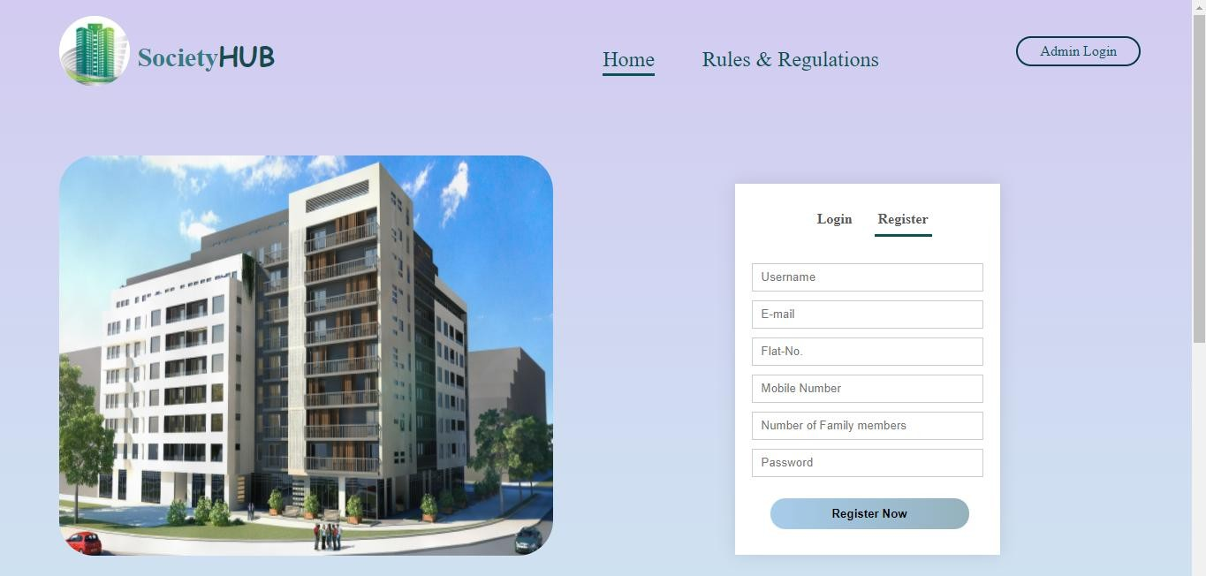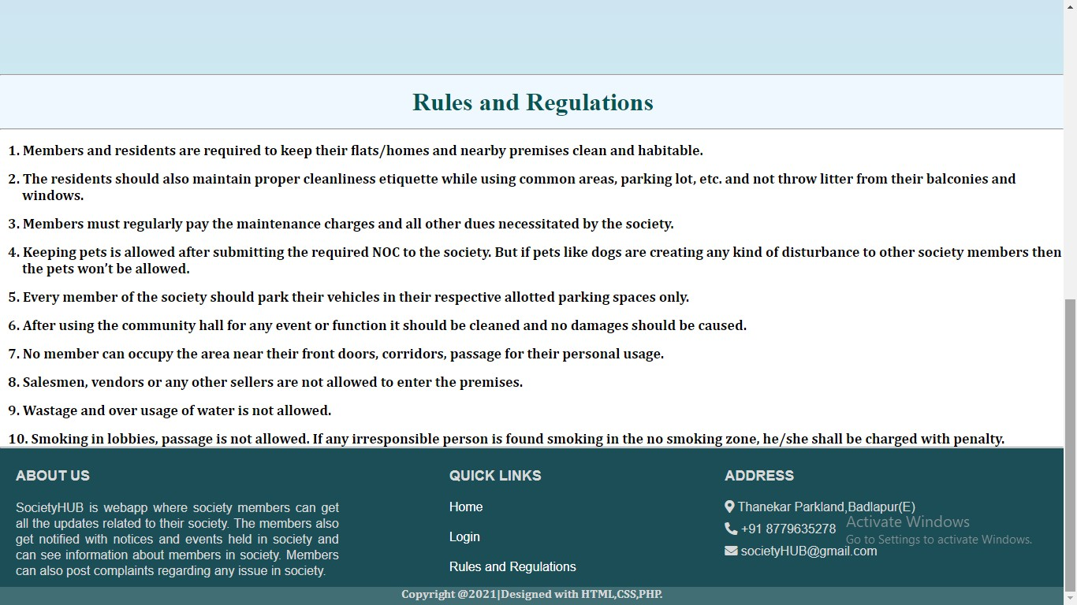

Home page

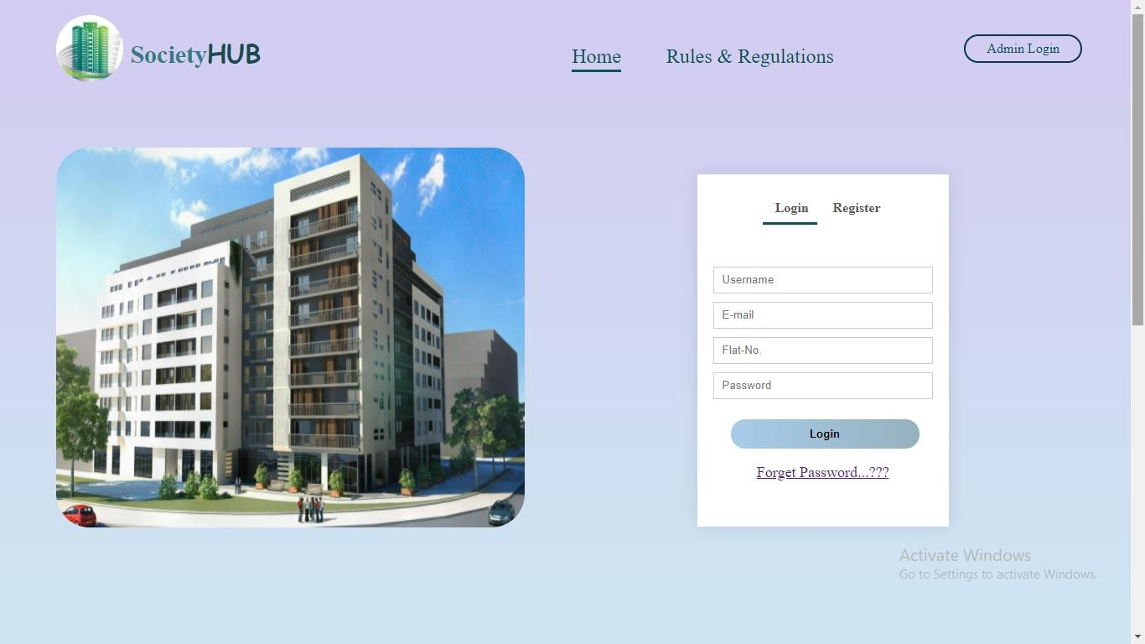

Member login page

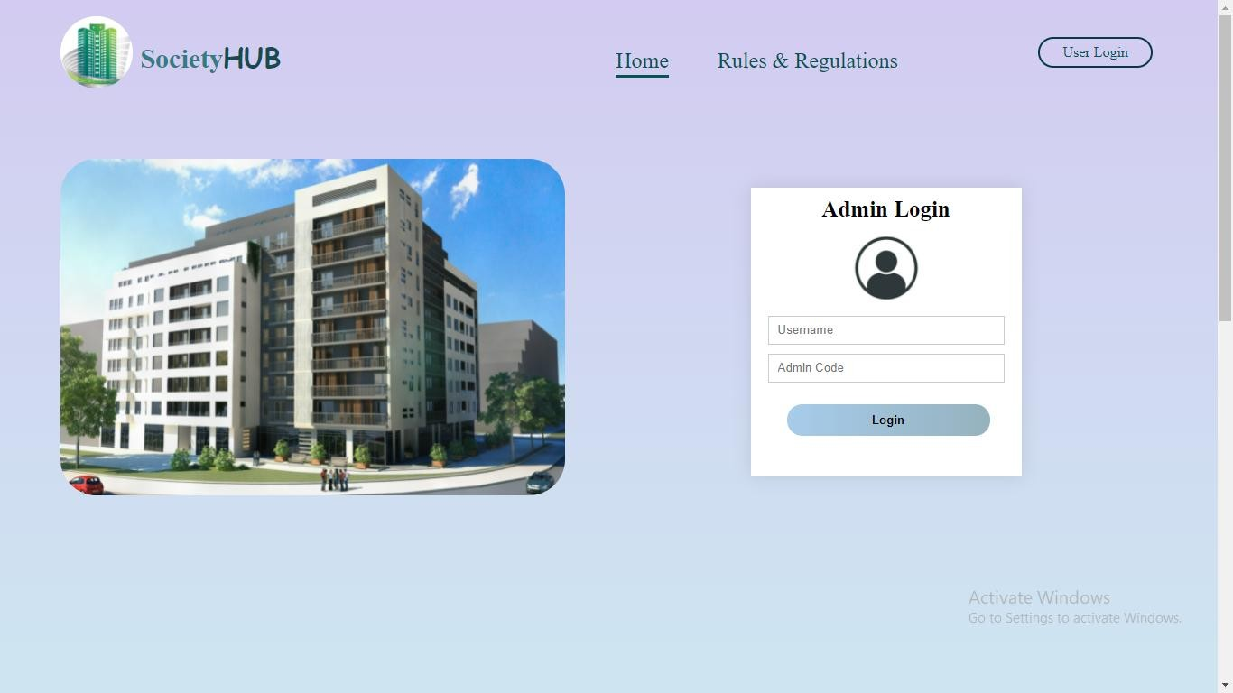

Admin login page

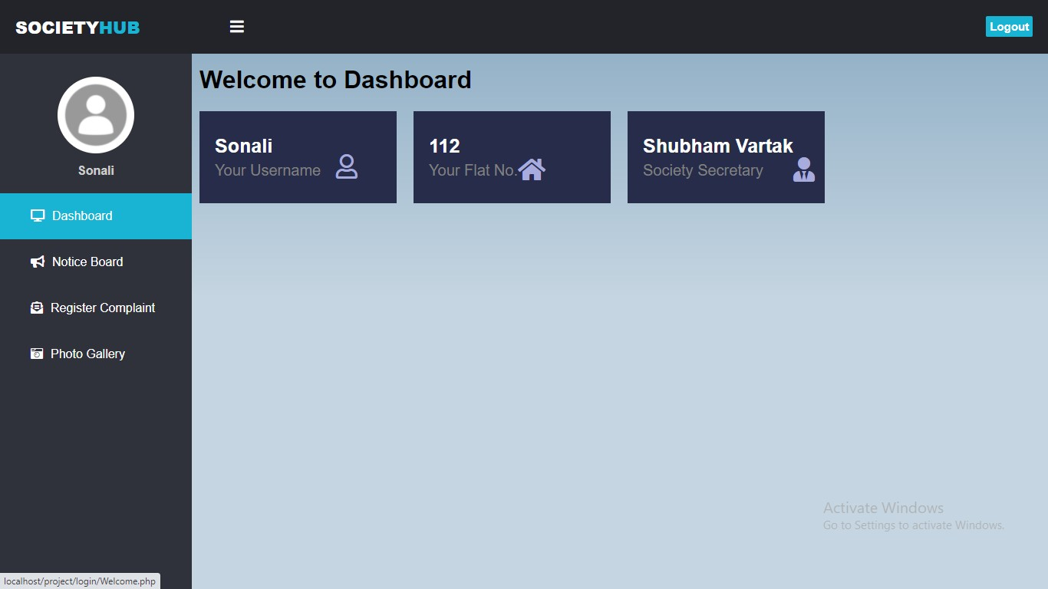

User dashboard page

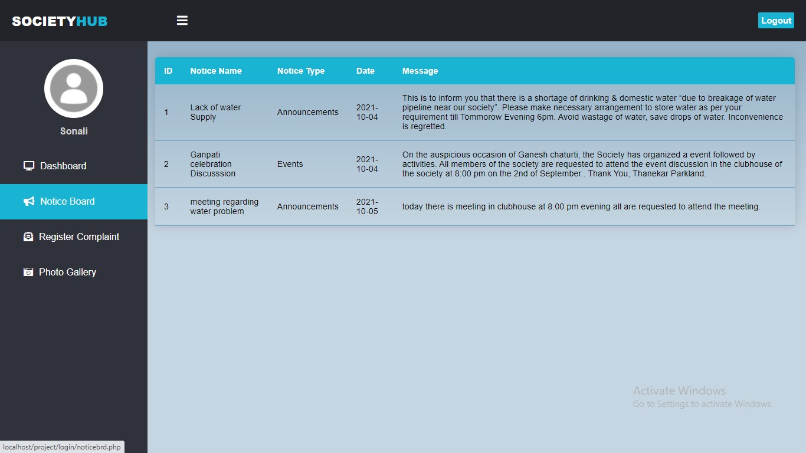

Notice board page

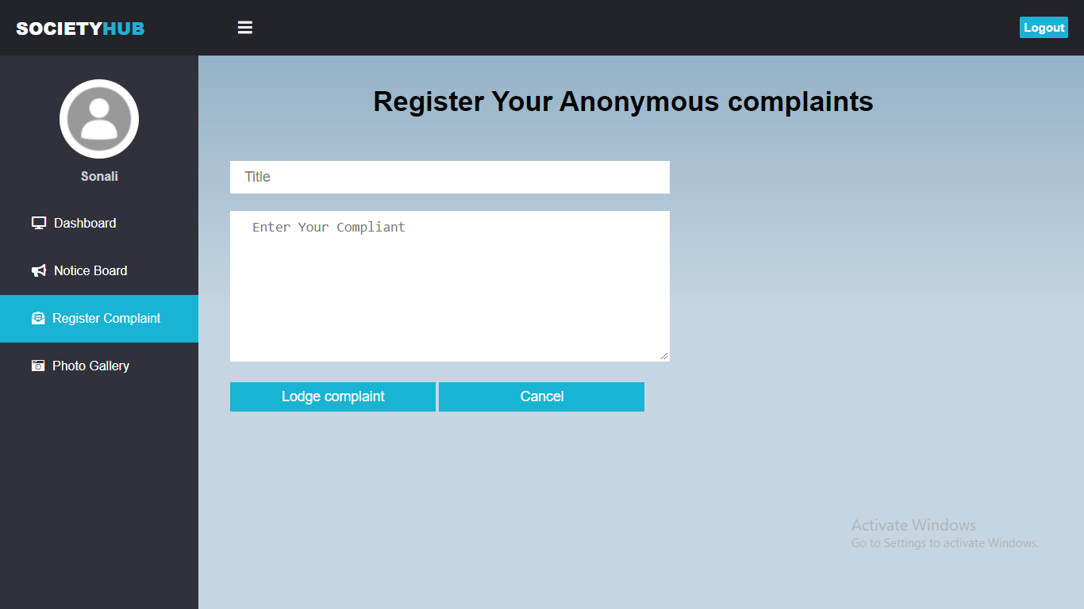

Register Complaint page

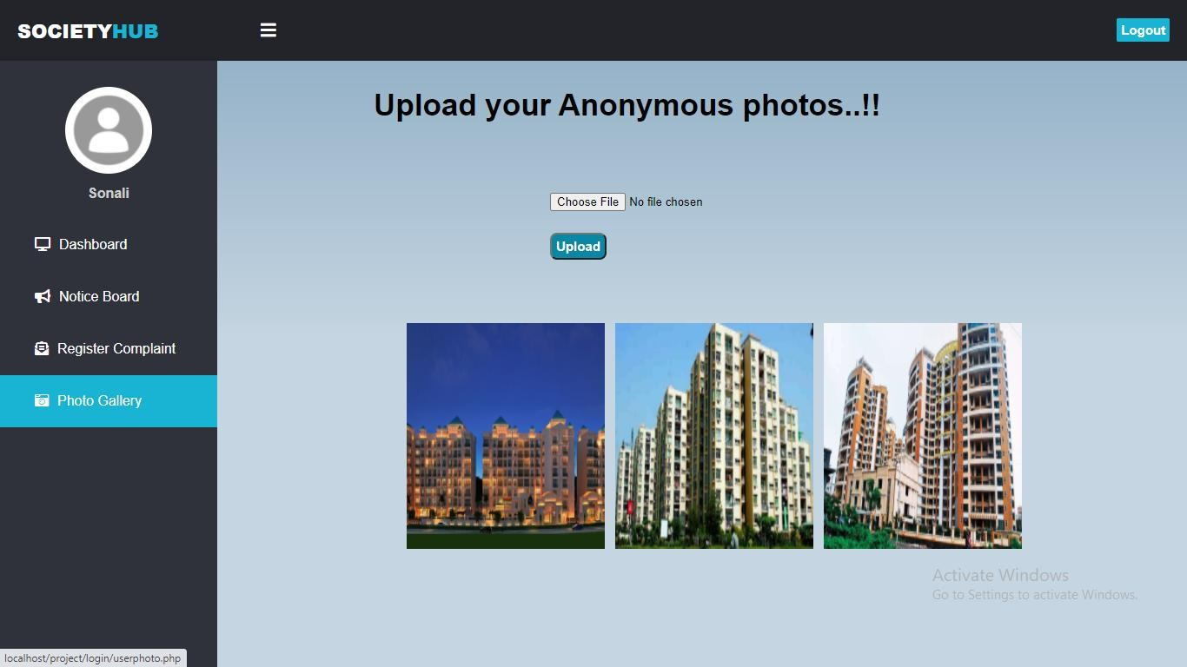

Photo Gallery page

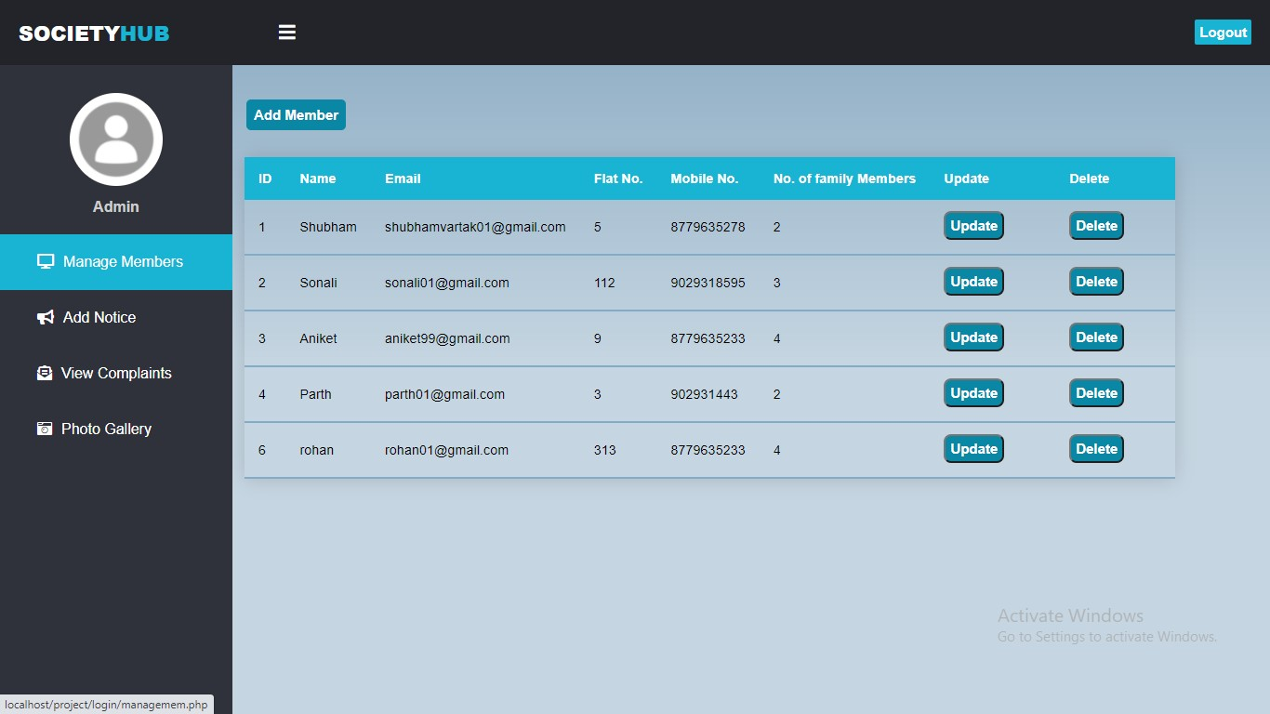

Admin manage Member page

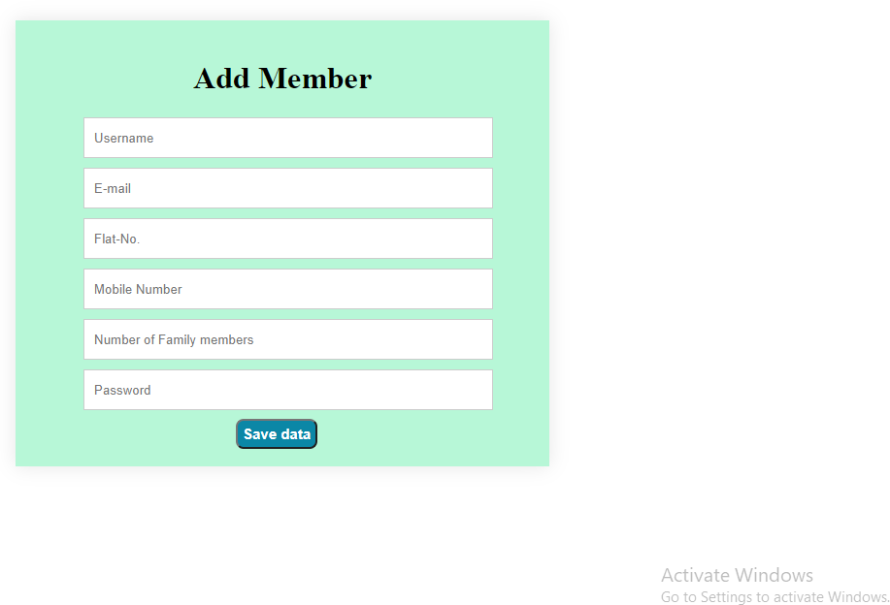

Admin Add member page (when Admin clicks on add member button).

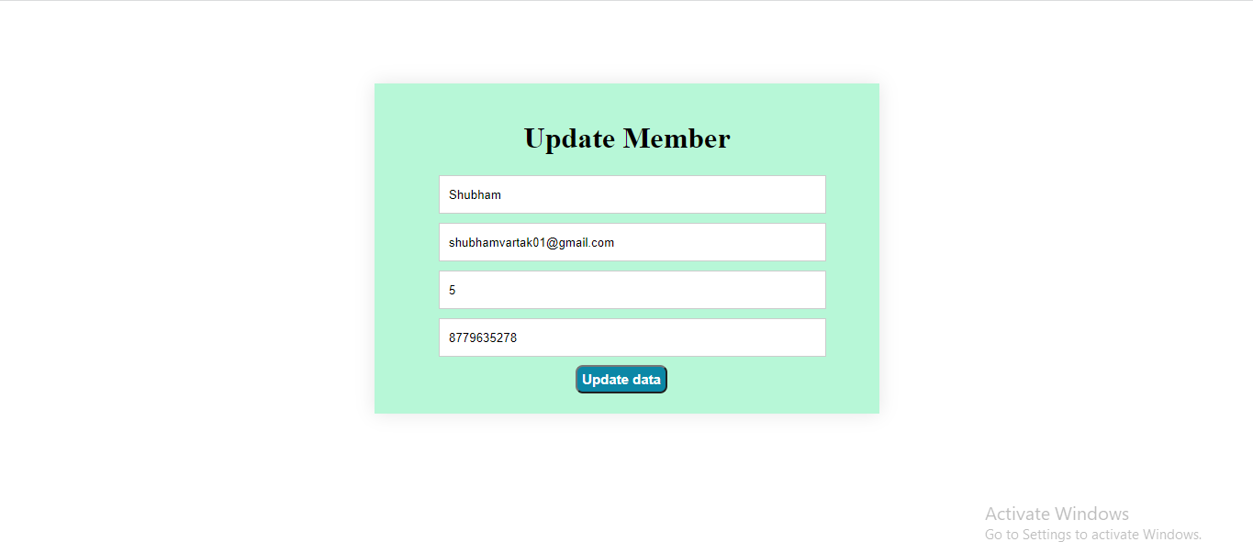

Admin update member page (When admin clicks on update button).

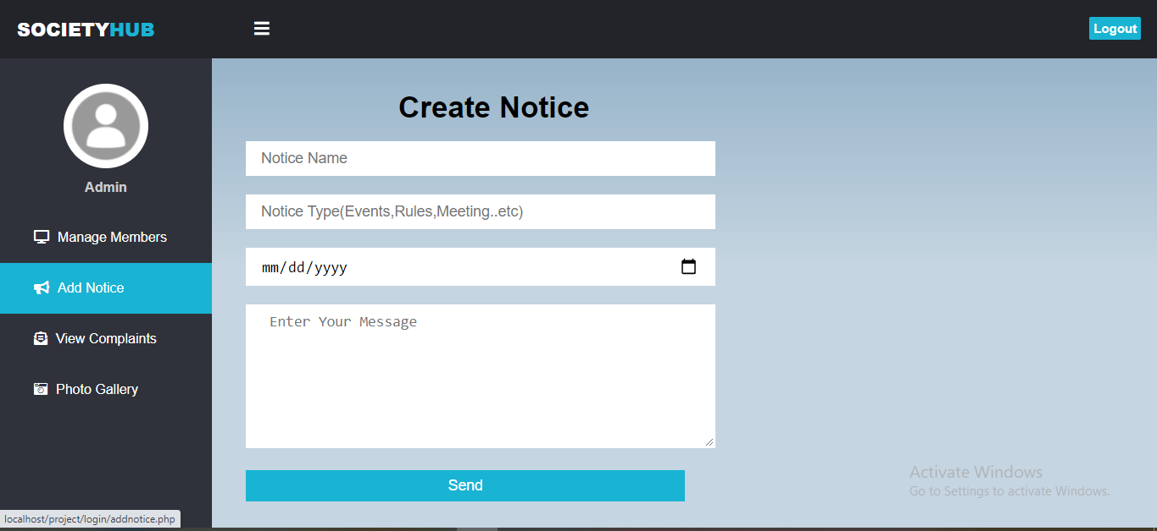

Admin add notice page.

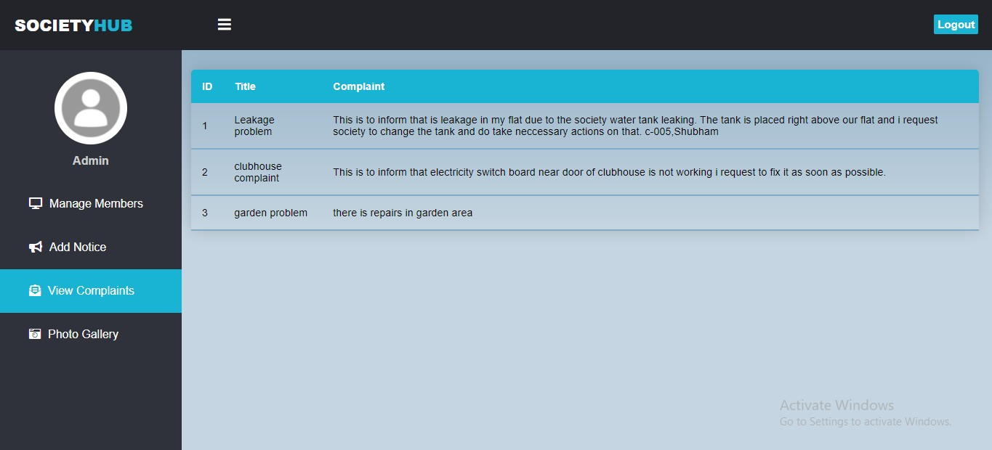

Admin view complaint page

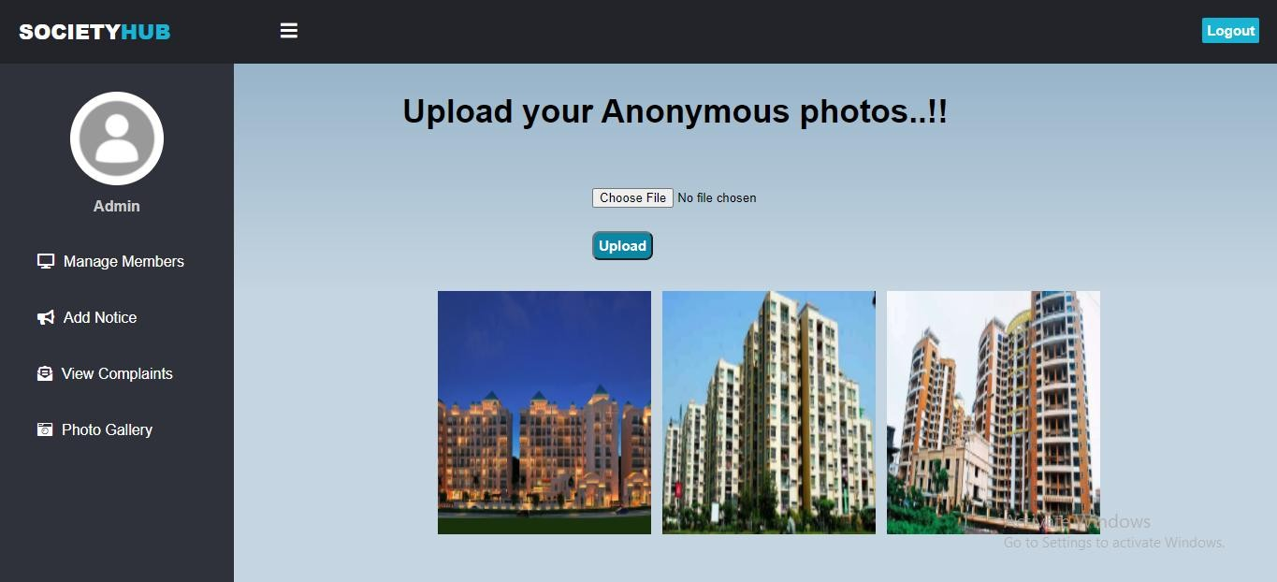

Admin photo gallery page

## Reports:

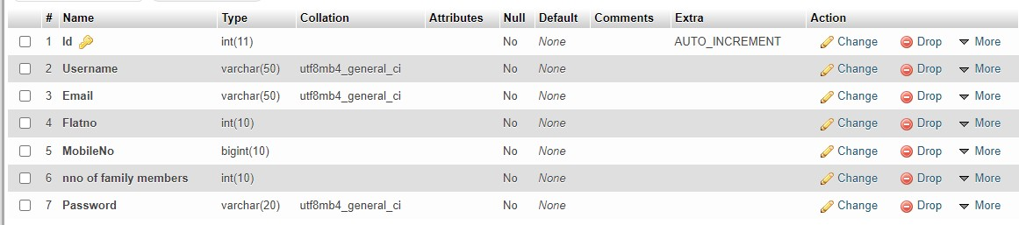

### 6.3.1- Registration Table

* + - Registration table is created where all the registered members details has been stored.
    - This table contains Id, Username, Email, Flatno, MobileNo, nno of family members, Password.
    - This data is retrieved from database through php and mysql.
    - The retrieved data from this table is displayed on the website in manage member page.

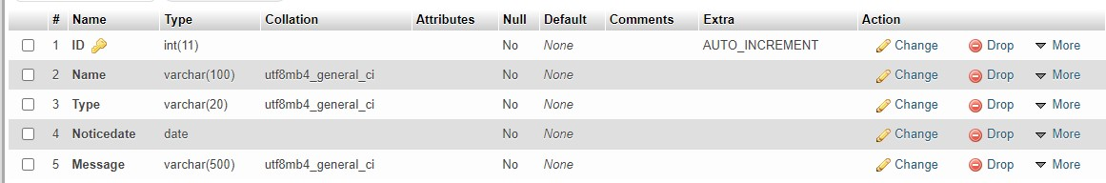

### – Notice table.

* + - * Notice table is created where all the notices has been stored.
      * This table contains ID, Name, Type, Noticedate, Message.
      * This data is retrieved from database through php and mysql.
      * The retrieved data from this table is displayed on the website in noticeboard page.



### – complaint table

* + - Complaint table is created where all the complaints by user has been stored.
    - This table contains id, title, complaint.
    - This data is retrieved from database through php and mysql.
    - The retrieved data from this table is displayed on the website in view complaint page.

# Future Enhancement

* + - This project can be enhanced further by adding online maintenance payment and receipt for that should be generated for every member to reduce the extra work of admin.
    - Message and email alerts for various happenings in the society can be added to the system so that users do not miss the updates and happenings of the society.
    - Parking management should be added to reduce parking issues.
    - Guest entry for every flat should be registered so that there will be no security issues.
    - Attending meeting online should be added to avoid get-together at meeting.

# Conclusion

* + - In the current phase of pandemic, systems like society management system are required to maintain society functioning smoothly.
    - This project reduces the manual work for managing society members records, passing notices to each member and also registering complaints.

# References

* + - <https://www.w3schools.com/php/>
    - <https://www.youtube.com/>
    - <https://www.tutorialspoint.com/>
    - <https://www.javatpoint.com/php-tutorial>
    - <https://www.w3schools.com/php/>

# Annexure

## Figure List:

|  |  |  |
| --- | --- | --- |
| **Figure Number** | **Name of Figure** | **Page Number** |
| 4.2 | Class Diagram | 10 |
| 4.3 | Use Case Diagram | 11 |
| 4.4 | Sequence Diagram | 12 |
| 4.5 | Activity Diagram | 13-14 |
| 4.6 | State Diagram | 15-16 |
| 4.7 | Package Diagram | 17 |
| 4.8 | Component Diagram | 18 |
| 4.9 | Deployment Diagram | 19 |

* 1. **Table List:**

|  |  |  |
| --- | --- | --- |
| **Table Number** | **Name of Table** | **Page Number** |
| 4.1 | Event Table | 8-9 |
| 4.10.1 | Database design: Members account | 20 |
| 4.10.2 | Database design: Notice Table | 20 |
| 4.10.3 | Database design: Complaints Table | 20 |
| 4.10.4 | Database design: Images Table | 20 |